Pittsburg State University, Electronics Engineering Technology

EET 640, Application Design Problems, 2016 Spring

Smart Brew

_____________________________

Andres Chu Wu

______________________________

Zhong Yan Shi

Due Date: 05/02/2016

For Use of Instructor:

Date Received: ___/___/___ Grade Assigned: ______

Remarks:

**Executive Summary**

This report presents the work of team Solution in Engineering Technology in the Application Design Problem course, EET 640, at Pittsburg State University in the spring of 2016. Solution in Engineering Technology, formed by two on campus students in the Electronics Engineering Technology program, were assigned the task of designing an automated herbal medicine brewer by the course instructors, Prof. Clark Shaver and Prof. Jim Lookadoo.

The team first started conducting a market research on products very similar in characteristics and reviews to get a handle on the problems and solutions that exist currently in the herbal medicine brewing market. With the information gathered from our initial market research, our team determined that similar products available do not support or offer a very basic form of automation control. From there, we focused on the problem stated and began to generate a list of specification to facilitate with our initial prototype of Smart Brew. The whole project was centered on these specification; circuit design, programming, calculations, and manufacturing design.

Moving forward from the initial market research, the team began developing the different functions that our prototype would need to carry out the specifications we had generated. These functions include the ability to transmit commands from a smartphone application, read and register temperature values, output actions according the registered values, and transmit back to the smartphone application. The large number of initial concepts was then trimmed to one solution by evaluating them against our specification and also respect our team’s mission statement of using open source systems. The selected solution was to create an automated control system with the aid of the Arduino environment and be implemented into our prototype.

The team determined that designing a technology that would be added to the herbal medicine field would allow for a product to stay relevant regardless of how many people do believe in holistic medicine, since there are many applications were our product may be inserted. We began working on the actual build of Smart Brew while nailing down other aspects of the project that includes: bill of materials, project schedule, and a market report. After the prototype was finished, our team then identified what further work can be done to bring the product to market. Finally, our team reflected on the prototype and process as a whole including what was done well and what could have been done more efficiently.

Contents

Executive Summary

1 – Project Concept…………………………………………………………………………pg. 8

* 1. – Abstract…………………………………………………………………………pg. 8
  2. – Introduction……………………………………………………………………..pg. 8
  3. – Project Idea Development………………………………………………………pg. 8
  4. – Team Organization…………………………………………………………….,.pg. 8

1. – Conceptual Design……………………………………………………………………..pg. 10
   1. – Primary Specification…………………………………………………………..pg. 10
   2. – Secondary Specification………………………………………………………..pg. 11
   3. – List of Applicable Standards…………………………………………………...pg. 11
2. – Preliminary Design…………………………………………………………………….pg. 13
   1. – Conceptual Design……………………………………………………………..pg. 13
      1. – Design Process……………………………………………………..pg. 14

3.1.1a – Wireless Connection………………………………………..pg. 14

3.1.1b – Brewing Profile……………………………………………..pg. 14

3.1.1c – Main Ingredient……………………………………………..pg. 14

3.1.1d – Brewing Process…………………………………………….pg. 15

3.1.1e – Sensitive Ingredient…………………………………………pg. 15

3.1.1f – Final Brewing Process………………………………………pg. 15

* 1. – Qualification Test Plan………………………………………………………...pg. 16

3.2.1 – Primary Specification Test…………………………………………...pg. 16

3.2.2 – Secondary Specification Test………………………………………...pg. 21

1. – Detailed Design………………………………………………………………………...pg. 23
   1. – Engineering Simulation………………………………………………………..pg. 23

Circuit Design……………………………………………………………………pg. 23

PCB Design………………………………………………………………………pg. 24

Android Application Layout……………………………………………………..pg. 25

Smart Brew Solidwork Design…………………………………………………..pg. 26

4.2 – Programming Code…………………………………………………………….pg. 29

4.2.1 – Smart Brew Arduino Code…………………………………………..pg. 29

4.2.2 – Android Studio Code………………………………………………...pg. 29

1. – Qualification Test Report……………………………………………………………...pg. 30

Test 1…………………………………………………………………………………pg. 30

Test 2…………………………………………………………………………………pg. 33

Test 3…………………………………………………………………………………pg. 36

Test 4…………………………………………………………………………………pg. 39

Test 5…………………………………………………………………………………pg. 42

Test 6…………………………………………………………………………………pg. 45

Test 7…………………………………………………………………………………pg. 48

Appendix A…………………………………………………………………………………..pg. 51

Appendix B…………………………………………………………………………………..pg. 53

Appendix C…………………………………………………………………………………..pg. 55

Appendix D…………………………………………………………………………………..pg. 57

Appendix E…………………………………………………………………………………..pg. 77

Appendix F………………………………………………………………………………….pg. 100

Appendix G…………………………………………………………………………………pg. 103

Appendix H…………………………………………………………………………………pg. 105

Appendix I………………………………………………………………………………….pg. 109

**List of Figures**

**Figure 1:** Solution in Engineering Technology Logo………………………………………...pg. 9

**Figure 2:** Basic Function Block Diagram…………………………………………………...pg. 13

**Figure 3**: Smart Brew Circuit Design……………………………………………………….pg. 23

**Figure 4**: Smart PCB Schematic with Altium Designer…………………………………….pg. 24

**Figure 5**: Smart Brew Android Application..………………………………………………..pg. 25

**Figure 6**: Smart Brew Solidwork Design…………………………………………………...pg. 26

**Figure 7**: Smart Brew Base 1 Design in Solidworks………………………………………..pg. 26

**Figure 8**: Smart Brew Base 2 Solidwork Design……………………………………………pg. 27

**Figure 9**: Smart Brew Ingredient Cart Solidwork Design ………………………………….pg. 27

**Figure 10**: Smart Brew Top Encasing 1 Solidwork Design...................................................pg. 28

**Figure 11**: Smart Brew Top Encasing 2 Solidwork Design………………………………...pg. 28

**Figure 12**: Smart Brew Top Encasing 3 Solidwork Design………………………………...pg. 29

**Figure 13**: HC-06 Bluetooth Module Pin Out………………………………………………pg. 30

**Figure 14**: Smartphone Interface Test Built Circuit………………………………………...pg. 31

**Figure 15**: Simple Android Smartphone Application with six button ……………………..pg. 32

**Figure 16**: 20X4 LCD Pin Layout………………………………………………………….pg. 33

**Figure 17**: Wire Diagram of DS18B20……………………………………………………..pg. 34

**Figure 18**: Arduino Uno using a DS18B20 Transducer and Displaying Temperature Values on LCD………………………………………………………………………………………….pg. 34

**Figure 19**: HC-06 Bluetooth Module Pin Out……………………………………………….pg. 36

**Figure 20**: Smartphone Interface Test Built Circuit…………………………………………pg. 37

**Figure 21**: Observed LEDs State for Physical Temperature Profile………………………...pg. 38

**Figure 22**: HC-06 Bluetooth Module Pin Out………………………………………………pg. 39

**Figure 23**: Smartphone Interface Test Built Circuit…………………………………………pg. 40

**Figure 24**: Observed LEDs State for Common Temperature Profile………………………..pg. 41

**Figure 25**: HC-06 Bluetooth Module Pin Out……………………………………………….pg. 42

**Figure 26**: Smartphone Interface Test Built Circuit…………………………………………pg. 43

**Figure 27**: Observed LEDs State for Supplement Temperature Profile…………………….pg. 44

**Figure 28**: HC-06 Bluetooth Module Pin Out……………………………………………….pg. 45

**Figure 29**: Smartphone Interface Test Built Circuit…………………………………………pg. 46

**Figure 30**: Observed LEDs State for Custom Temperature Profile…………………………pg. 47

**Figure 31**: Diode and Transistor Circuit Diagram…………………………………………..pg. 48

**Figure 32**: 20X4 LCD Pin Layout…………………………………………………………...pg. 49

**Figure 33**: Arduino MEGA using a DS18B20 Transducer and Displaying Temperature Values on LCD……………………………………………………………………………………….pg. 49

**Figure 34:** Temperature vs Time Brewing Profile…………………………………………..pg. 53

**Figure 35:** Temperature vs Time Brewing Profile…………………………………………..pg. 53

**Figure 36:** Temperature vs Time Brewing Profile…………………………………………..pg. 54

**Figure 37:** Temperature vs Time Brewing Profile…………………………………………..pg. 54

**Figure 38:** Smart Brew Input and Output Block Diagram…………………………………..pg. 55

**Figure 39**: Smart Brew Simple Flow Chart…………………………………………………pg. 55

**Figure 40:** Android Application Flowchart…………………………………………………pg. 56

**List of Tables**

**Table 1**: Pre-determined Pattern for Physical Temperature Profile…………………………pg. 17

**Table 2**: Pre-determined Pattern for Common Temperature Profile………………………...pg. 18

**Table 3**: Pre-determined Pattern for Supplement Temperature Profile……………………...pg. 19

**Table 4**: Pre-determined Pattern for Custom Temperature Profile………………………….pg. 20

**Table 5**: Gather Results from Smartphone Interface Test…………………………………...pg. 31

**Table 6**: Distance from Base of the Herbal Pot to Different Water Volume………………..pg. 35

**Table 7**: Initial and Measured Temperature at Different Water Volume……………………pg. 35

**Table 8**: Pre-determined Pattern for Physical Temperature Profile…………………………pg. 37

**Table 9**: Pre-determined Pattern for Common Temperature Profile………………………...pg. 40

**Table 10**: Pre-determined Pattern for Supplement Temperature Profile…………………….pg. 43

**Table 11**: Pre-determined Pattern for Custom Temperature Profile………………………...pg. 46

**Table 12**: Results from Test Display Current Temperature and State of LED……………...pg. 50

**1 – Project Concept**

* 1. **– Abstract**

The herbal medicine field is an ancient art that seeks to cure various illnesses with natural ingredients. Nowadays, we can observe that there’s a strong demand for natural and organic products implying that, there’s also an increasing need for appliances that properly prepares these special ingredients. It’s known that different roots and herbs have different levels of heat sensitivity, so the preparation of an herbal tea would require time, skill and knowledge from the user in order to extract all the healing properties from these ingredients. Smart Brew is specially designed to solve these hassles; it is an automated system that will aid in the preparation of these ingredients by controlling the checking the development process through an app, therefore optimizing the quality of the drinks and minimizing waste of the ingredients. It’s a product that will modernize the traditional market of herbal medicine and facilitate the lives of many consumers interested in health products.

* 1. **– Introduction**

Smart Brew is a completely autonomous herbal medicine brewer. This device contains four major components. The first is a heat source. The second component is the compartments in which ingredients will be stored. The third component consists of sensors in which data will be collected. And the last component is the communication between the user and machine through a smartphone application.

**1.3 – Project Idea Development**

At the start of the course, the team was task to think of five project concepts for this course. These five ideas include the following:

1. Smart Herbal Medicine Brewer
2. Automated Indoor Irrigation System
3. Smart Door Lock
4. Smart Water Bottle Cap
5. Ventilation Project offered from the course instructors

After presenting these ideas to the course instructors, they gave the team verbal permission to pursue the Smart Herbal Medicine Brewer project. The reason the team listed the Smart Herbal Medicine Brewer at the top at the list is due to the cultural knowledge behind herbal medicine and also the lack of this product in the current market.

**1.4 – Team Organization**

The first team meeting was held at the Leonard H. Axe Library at Pittsburg State University. During this meeting, several topics were discussed in order to help the team stay organized:

1. Establishing means of communication
2. Create a team charter
3. Setting project schedules and gate presentation deadlines
4. Create an account on Dropbox for the team in which each member would collectively store documentation.
5. Division of Labor and Cost
6. Team name and logo

Each member of the team was responsible for communicating with each other to ensure the each member was working as one cohesive unit. The team met according to their class schedule and availability in order to meet the deadlines for each Gate as outlined in the team charter shown in Appendix A. Also, the team settled on a team name, Solution in Engineering Technology, and a design for the logo depicted below in Figure 1.



**Figure 1**: Solution in Engineering Technology Logo

**2 - Conceptual Design**

**2.1 – Primary Specification**

1. Product will support 4 brewing regions with distinct temperature profile to user’s preference:
   1. Brewing region for Physical Illness with a brewing temperature profile setting as given in Appendix B (± 2° C).
   2. Brewing region for Common Illness with a brewing temperature profile setting as given in Appendix B (± 2° C).
   3. Brewing region for Supplement with a brewing temperature profile setting as given in Appendix B (± 2° C).
   4. Brewing region for Custom with a brewing temperature profile setting as given in Appendix B (± 2° C).
      1. Ex:
         1. Main ingredients need 1 hour of pre immersion.
         2. Boil for 30 minutes.
         3. Simmer for 50 minutes.
         4. Dispense sensitive ingredients.
         5. Keep warm for 10 minutes.
2. Product will support 2 separate storage compartment:
   1. First compartment will store up to 4 main ingredient bags.
      1. Fist compartment will be dispensed at the start of the brewing process for pre immersion.
   2. Second compartment will store 4 sensitive ingredient bags.
      1. Second compartment will be dispensed during the remaining 10 minutes of the total brewing time.
3. Product will support a water pump to fill medical pot:
   1. Water level is filled up to 85% of the total volume to begin brewing process (± 5%).
   2. Water level cannot drop more than 35% of the total volume during brewing process (± 5%).
4. Product will support an Android based phone Application:
   1. Application will serve as a mean of communication between product and user.
      1. User can set one of the 4 brewing regions (Physical Illness, Common Illness, Supplement, and Custom).
      2. In Custom brewing region, user can manually set:
         1. Time settings
         2. Temperature settings
         3. Override brewing process

**2.2 – Secondary Specification**

1. Product will support a water pump to fill medical pot for a strong or bland taste:
   1. For a stronger taste, water level is filled up to 75% of total volume (± 5%).
      1. Ex: 1.5L in a 2L medical pot.
   2. For a bland taste, water level is filled up to 85% of total volume (± 5%).
      1. Ex: 1.7L in a 2L medical pot.
2. Product will support a touch screen interface:
   1. User can set one of the 4 brewing regions (Physical Illness, Common Illness, Supplement, and Custom).
   2. In Custom brewing region, user can manually set:
      1. Time settings
      2. Temperature settings
      3. Override brewing process

**2.3 – List of Applicable Standards**

1. IEEE 802.15.4 Networking Protocol for Fast Point-to-Multipoint or Peer-to-Peer Networking
2. IEEE 802.15.1 WPAN/ Bluetooth
3. ASTM C1359 -13 Standard Test Method for Monotonic Tensile Strength Testing of Continuous Fiber-Reinforced Advanced Ceramics
4. ASTM D10442-12 Standard Test Method for Linear Dimensional Changes of Plastics Caused by Exposure to Heat and Moisture
5. ASTM D50 -98 Standard Test Method for Water Absorption of Plastics
6. ASTM D3045 -92 Standard Practice of Heat Aging of Plastics Without Load
7. ASTM D4092 -07 (2013) Standard Terminology for Plastic: Dynamic Mechanical Properties

Note: ASTM – American Society for Testing and Materials

**3 – Preliminary Design**

**3.1 – Conceptual Design**

The design can be divided into three major functions: inputs, process, and output. Each significant function will contain several key components that will be combined and developed into a functioning prototype. First, in order to handle processing and communication between inputs and outputs, the use of microcontrollers will be integrated in the system. With the assistance of microcontrollers, it will make the project more manageable in the time assigned.



**Figure 2:** Basic Function Block Diagram

The inputs for the functioning prototype will be made up of three components: temperature sensor (DS18B20 Thermometer), wireless module (HC-06 Bluetooth Module), and switches. Every processing done by Smart Brew will be handled by an embedded microcontroller, specifically the Atmel Atmega 2560. This specific chip is used on the Arduino Mega development boards for its reliability and flexibility to handle basic functions. Also another key reason Smart Brew uses the Atmega 2560 is because of its reasonable price. Price is a very important factor in this prototype: if the overall costs can be reduced, so can be the price of the final product.

For the outputs section, this prototype will have four components. The first component is the LCD screen. The use of this screen will provide visual information on several functions Smart Brew. The second component is the heating element that will consist of a ceramic heater plate. For the third component, a water pump will be installed to fill the medical pot at the desired setting. For the final component, a small motor for the opening and closing of the ingredient compartments. Appendix C depicts the input/output block diagram for the Atmega 2560.

**3.1.1 – Design Process**

After determining the inputs and outputs the team began developing the system for Smart Brew. A simple flowchart as seen in Appendix C demonstrates how the Smart Brew will perform. The first step is to establish the wireless connection between the smartphone application and the prototype. When connection is established, the following step is to inform Smart Brew of the brewing profile the user has selected. When selected, Smart Brew will begin the brewing process and dispense the Main Ingredients. As soon as the brewing process concludes, Smart Brew will keep the concoction at an appropriate temperature in case the user is not around to consume it immediately.

**3.1.1a – Wireless Connection**

A smartphone application was designed in Android Studio in order to interact with Smart Brew. When the application is initialized, the first step is to ask the user to establish the Bluetooth connection with the prototype. When this connection is established, the application will allow the user to selected their desired profile. The flowchart for the Android application can be seen in Appendix C.

**3.1.1b – Brewing Profile**

Each brewing profile has its unique temperature profile that has been programed as seen in Appendix B. For the Physical Illness, Common Illness, and Supplement temperature profiles are profiles that are programmed into Smart Brew and no possible customization will be allowed. The Custom Profile is the only brewing profile that will allow the user set its personal settings; setting temperature (in Celsius) and brewing time length.

**3.1.1c – Main Ingredient**

After choosing the desired brewing profile, Smart Brew will begin filling the ceramic pot to 85% of its total volume with water. When the water level has reached, Smart Brew will begin to dispense the main medicine bag and start the pre-soak process. During the pre-soak process, the medicine bag sits inside the water-filled ceramic pot for at least an hour. Note that the heating element will not start until the one-hour mark has been reached.

**3.1.1d – Brewing Process**

When the main ingredient has been pre-soaked for an hour, Smart Brew will initialize the brewing process. As describe earlier in 3.1.1b, each brewing profile has a unique temperature profile. These temperature profiles are considered one of the key functions of Smart Brew. Without these profiles, the extraction of these ingredients won’t be maximized. In the brewing process, Smart Brew will constantly check if the water level has not drop to a critical level at 35% of the total volume of the ceramic pot and the temperature. Also it will be checking to see if the user has paused the brewing process.

**3.1.1e – Sensitive Ingredient**

Apart from the main ingredients, that require extensive time to brew, there are also ingredients that do not require. These ingredients are described as ‘sensitive ingredients’. Smart Brew will only dispense the sensitive ingredient medicine bag if the user had selected prior to the brewing process. If the user did select the presence of sensitive ingredients, Smart Brew will dispense during the remaining ten minutes of the total brew time.

**3.1.1f – Final Brewing Process**

When the brewing process has finalized, Smart Brew will begin to set the temperature at a ‘keep warm’ setting. This setting will set the heating element to maintain at 50° Celsius ($± 2°)$. The team members think that at this temperature it is ideal for consumption for the user. Smart Brew will also be constantly checking for drop in temperature inside the ceramic pot and turn the heating element when necessary.

**3.2- Primary Specification Test**

**Specification:** Test 1

**Test Name**: Smartphone Interface Test

**Objective**: Does the smartphone application have the necessary button interfaces and also test Bluetooth communication between application and board.

**How is the test performed:**  Connect a wireless module to an array of LEDs. Connect the smartphone application to the wireless module to observe if the LED’s turn on or off.

**What data will be retrieved from test:**

|  |  |  |
| --- | --- | --- |
|  | Is Button Present? | Does Button Work? |
| Physical Profile | Y / N | Y / N |
| Common Profile | Y / N | Y / N |
| Supplement Profile | Y / N | Y / N |
| Custom Profile | Y / N | Y / N |
| Pause | Y / N | Y / N |
| Resume | Y / N | Y / N |

**Acceptance Criteria**: All button must be present on the application and be able to turn on their assigned LED in order for the test to pass. Otherwise the test has failed.

**Specification**: Test 2

**Test Name**: Water Level Test

**What is to be learned from this test**: Can the prototype detect water level inside the herbal pot.

**How is the test performed:**On the side of the pot, two thermistor will be place at specific position, this will allow the automated herbal pot know when the water reached a certain amount.

**What data will be retrieved from test?**

|  |  |  |
| --- | --- | --- |
|  | Initial Resistance | Reached Resistance |
| 0.7 L (35%) |  |  |
| 1.7 L (85%) |  |  |

**Acceptance Criteria**: Comparing the initial temperature and the detected temperature. If the values did change, the test is successful. If the temperatures values did not change, the test has failed.

**Specification**: Test 3

**Test Name**: Brewing Profile Test #1

**What is to be learned from this test**: Can the Automated Herbal Pot perform the Physical temperature profile?

**How is the test performed:** A program will be written in the Arduino IDE that will mimic the physical illness temperature profile. On the development board, two LED (green and red) will be connected to indicate different temperatures. For example, if the program has reached a “temperature” of 100°C, the red LED should turn on and stay on for a determined time. When time is up, the LED should turn off.

**What data will be retrieved from test?**



**Table 1**: Pre-determined Pattern for Physical Temperature Profile.

**Acceptance Criteria**: If the LEDs does follow the pre-determined state of the LEDs, the test has passed, otherwise the test has failed.

**Specification**: Test 4

**Test Name**: Brewing Profile Test #2

**What is to be learned from this test**: Can the Automated Herbal Pot perform the Common temperature profile?

**How is the test performed:** A program will be written in the Arduino IDE that will mimic the physical illness temperature profile. On the development board, two LED (green and red) will be connected to indicate different temperatures. For example, if the program has reached a “temperature” of 100°C, the red LED should turn on and stay on for a determined time. When time is up, the LED should turn off.

**What data will be retrieved from test?**



**Table 2**: Pre-determined Pattern for Common Temperature Profile.

**Acceptance Criteria**: If the LEDs does follow the pre-determined state of the LEDs, the test has passed, otherwise the test has failed.

**Specification**: Test 5

**Test Name**: Brewing Profile Test #3

**What is to be learned from this test**: Can the Automated Herbal Pot perform the Supplement temperature profile?

**How is the test performed:** A program will be written in the Arduino IDE that will mimic the physical illness temperature profile. On the development board, two LED (green and red) will be connected to indicate different temperatures. For example, if the program has reached a “temperature” of 100°C, the red LED should turn on and stay on for a determined time. When time is up, the LED should turn off.

**What data will be retrieved from test?**



**Table 3**: Pre-determined Pattern for Supplement Temperature Profile.

**Acceptance Criteria**: If the LEDs does follow the pre-determined state of the LEDs, the test has passed, otherwise the test has failed.

**Specification**: Test 6

**Test Name**: Brewing Profile Test #4

**What is to be learned from this test**: Can the Automated Herbal Pot perform the Custom temperature profile?

**How is the test performed:** A program will be written in the Arduino IDE that will mimic the physical illness temperature profile. On the development board, two LED (green and red) will be connected to indicate different temperatures. For example, if the program has reached a “temperature” of 100°C, the red LED should turn on and stay on for a determined time. When time is up, the LED should turn off.

**What data will be retrieved from test?**



**Table 4**: Pre-determined Pattern for Custom Temperature Profile.

**Acceptance Criteria**: If the LEDs does follow the pre-determined state of the LEDs, the test has passed, otherwise the test has failed.

**Specification**: Test 7

**Test Name**: Heating Element Test

**What is to be learned from this test**: Can the prototype be able to turn on/off the heating element at a determined temperature.

**How is the test performed:** A simple ADC program in Arduino will be written to check a DS18B20 thermometer. The sensor will be measuring a heating element. When temperature has reached 25°C, an LED will turn on. As temperature rises to 100°C, the LED will turn off.

**What data will be retrieved from test:**

|  |  |  |
| --- | --- | --- |
| Temperature | Is LED on or off? | Resistance Value |
| 25°C |  |  |
| 100°C |  |  |

**Acceptance Criteria**: The test is successful if the LED is turned on at 25 °C and also if the LED is turned off at 100 °C.

**3.2 – Secondary Specification Test**

**Specification:** Test 8

**Test Name:** Water Level Taste Test

**What is to be learned from this test:** Can the prototype detect different water level inside the herbal pot?

**How is the test performed:**  On the side of the pot, two thermistor will be place at specific position. This will allow the automated herbal pot know when the water reached a certain amount.

**What data will be retrieved from test?**

|  |  |  |
| --- | --- | --- |
|  | Init. Resistance | Reach Resistance |
| 1.5 L (75%) |  |  |
| 1.7 L (85%) |  |  |

**Acceptance Criteria:** Comparing the initial resistance and reached resistance. If the values did change, the test is successful. If the resistance value did not change, the test has failed.

**Specification:** Test 9

**Test Name:** Touchscreen Brew Profile Selection Test

**What is to be learned from this test:** Does the touch screen have the necessary button interface and do each of these buttons properly function?

**How is the test performed:** Connect a wireless module to an array of LEDs. Connect the smartphone application to the wireless module to observe if the LED’s turn on or off.

**What data will be retrieved from test?**

|  |  |  |
| --- | --- | --- |
|  | Is Button Present? | Does Button Work? |
| Physical Profile | Y / N | Y / N |
| Common Profile | Y / N | Y / N |
| Supplement Profile | Y / N | Y / N |
| Custom Profile | Y / N | Y / N |
| Time | Y / N | Y / N |
| Temperature | Y / N | Y / N |
| Home | Y / N | Y / N |
| Pause | Y / N | Y / N |
| Resume | Y / N | Y / N |

**Acceptance Criteria:** All button must be present on the application and turn on the LEDs in order for the test to pass. Otherwise the test has failed.

**4 - Detailed Design**

**4.1 – Engineering Simulation**



**Figure 3**: Smart Brew Circuit Design.

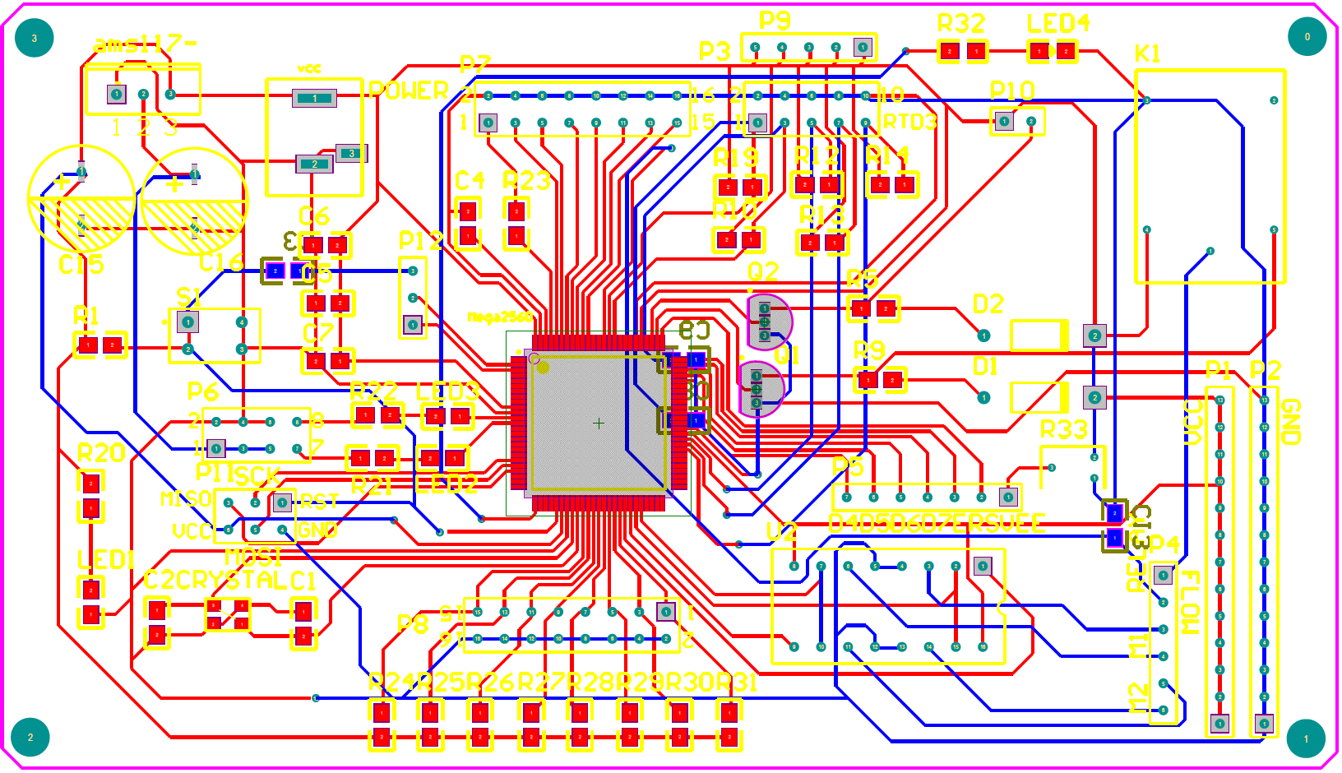

**Figure 4**: Smart Brew PCB Schematic with Altium Designer

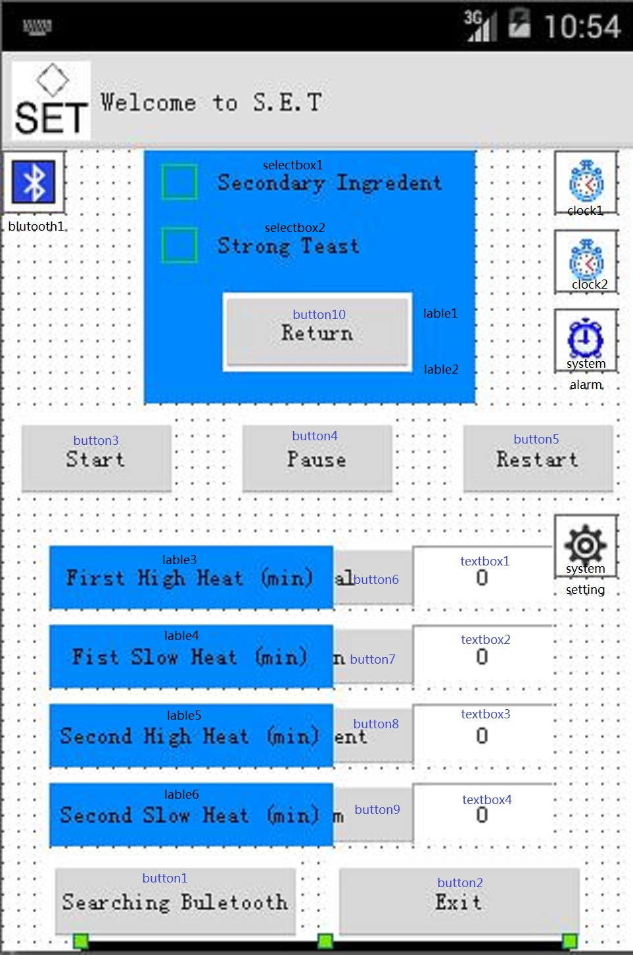

**Figure 5**: Smart Brew Android Application.

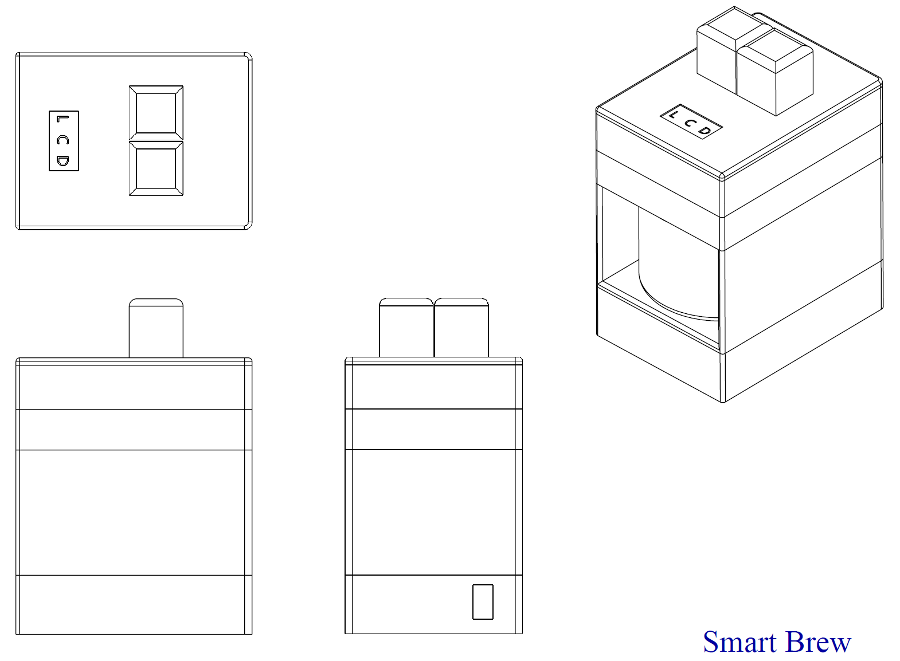

**Figure 6**: Smart Brew Solidwork Design

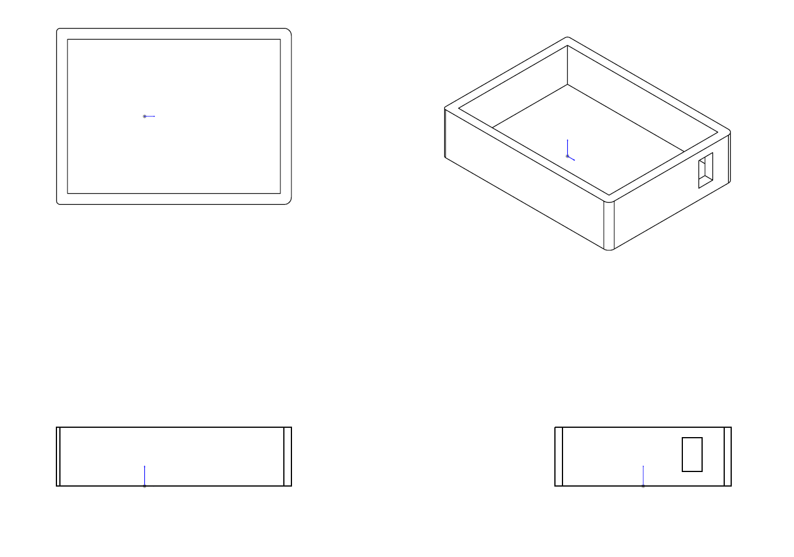

**Figure 7**: Smart Brew Base 1 Design in Solidworks.

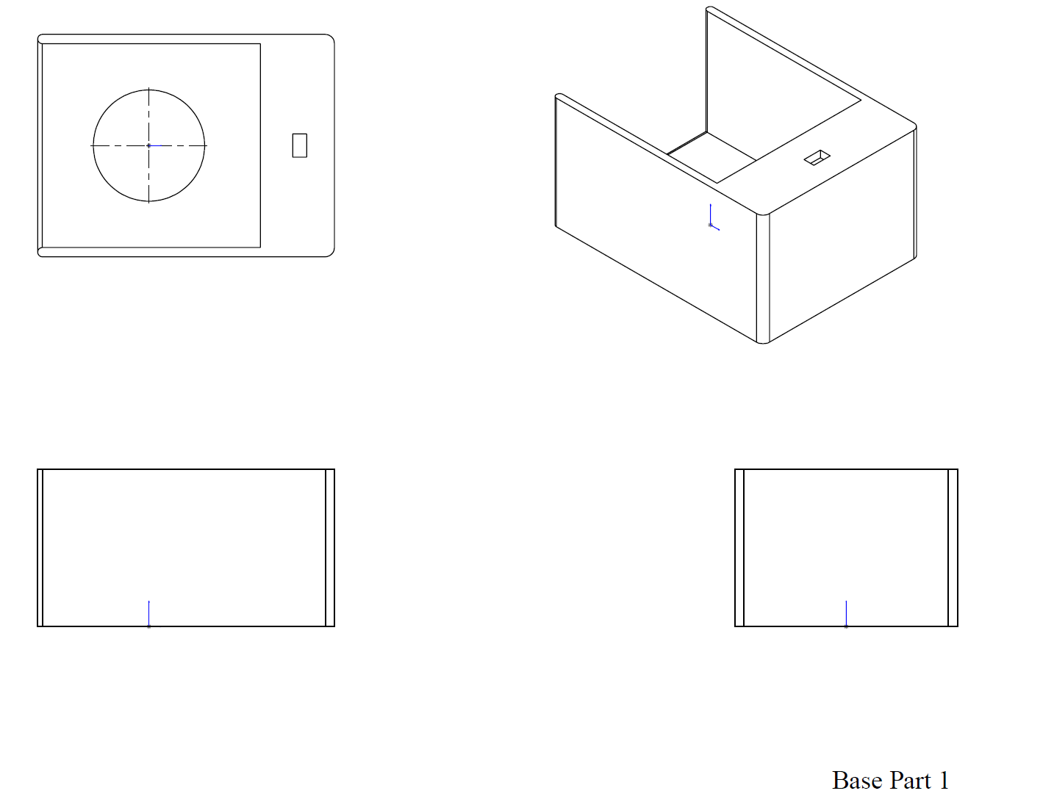

**Figure 8**: Smart Brew Base 2 Solidwork Design.

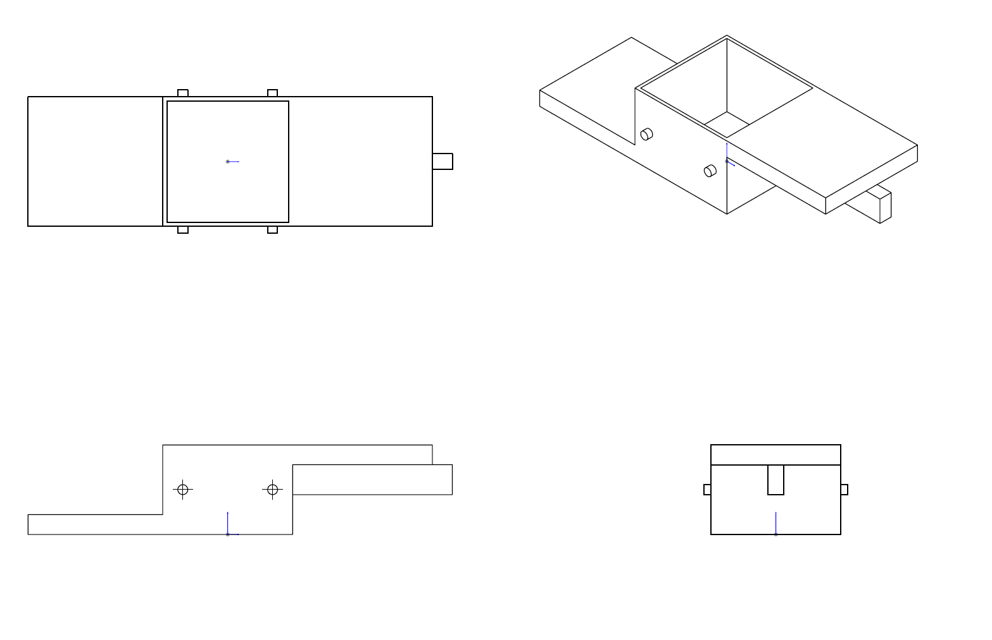

**Figure 9**: Smart Brew Ingredient Cart Solidwork Design.

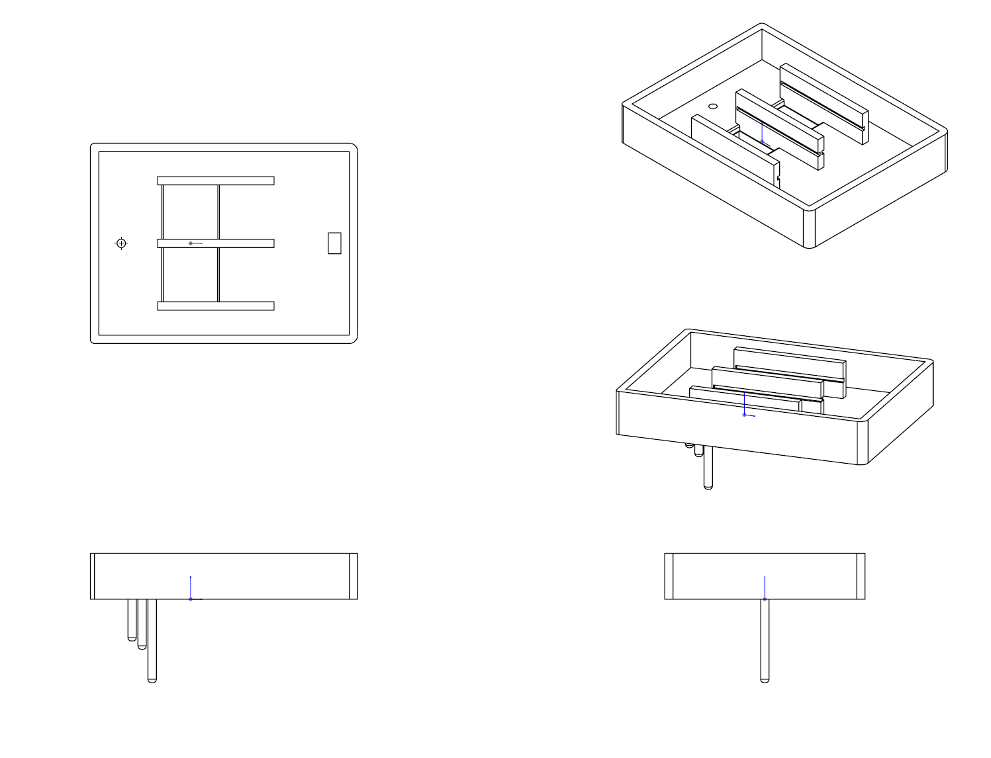

**Figure 10**: Smart Brew Top Encasing 1 Solidwork Design.

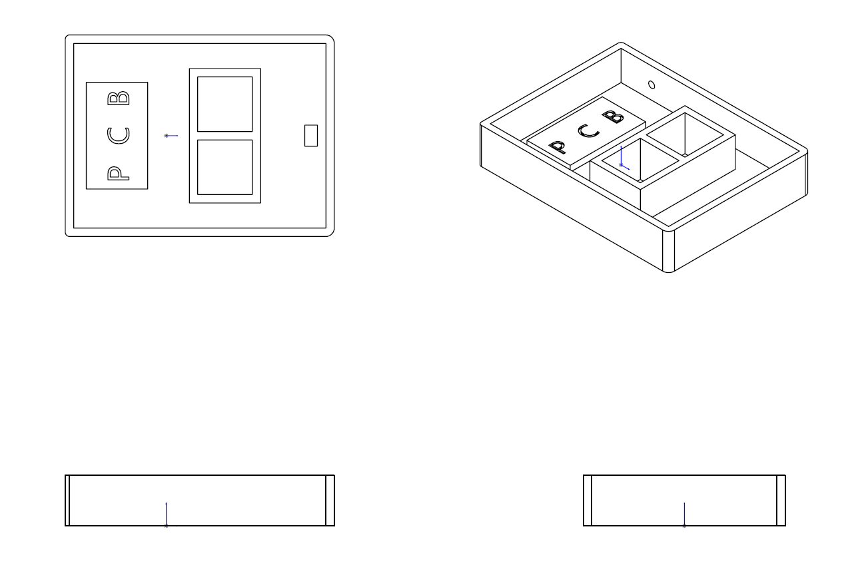

**Figure 11**: Smart Brew Top Encasing 2 Solidwork Design.

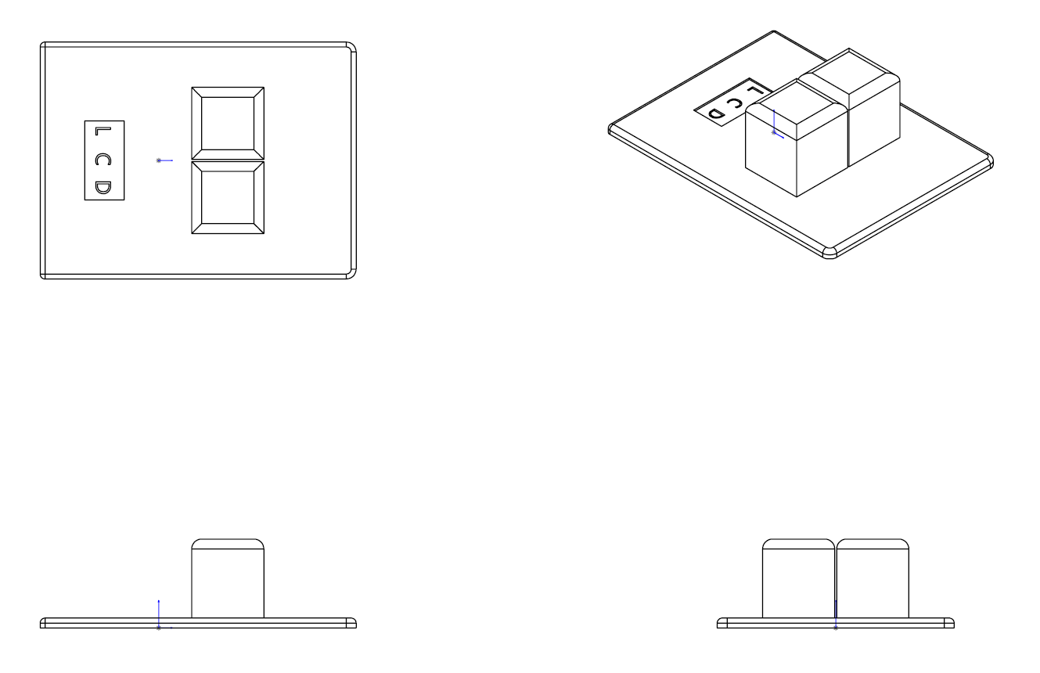

**Figure 12**: Smart Brew Top Encasing 3 Solidwork Design.

**4.2 – Programming Code**

**4.2.1 – Smart Brew Arduino Code**

The controls section of Smart Brew was programmed using Arduino IDE. The following code is located in Appendix D.

**4.2.2 – Android Studio Code**

For Smart Brew’s companion App, the team decide to use an Android platform. The reason for this platform was due to the free-of-charge development of the application and also due to its flexibility with open source hardware. The following code is located in Appendix E.

**5 – Qualification Test Report**

**Specification:** Test 1

**Test Name**: Smartphone Interface Test

**Objective**: Does the smartphone application have the necessary button interfaces and also test Bluetooth communication between application and board.

**Acceptance Criteria**: All button must be present on the application and be able to turn on their assigned LED in order for the test to pass. Otherwise the test has failed.

**Equipment List**:

* Arduino Uno
* 220 Ω Resistor (6)
* 3 Green LED
* 2 Red LED
* 1 Yellow LED
* HC-06 Bluetooth Module
* Android Smartphone Application

**Procedure**:

1. Include Wire library in Arduino Program

2. Set Arduino UNO digital pin (13 – 8) to Output

3. Connect 220 Ω Resistors and LEDs to each of the following digital pins in Procedure 2.

4. Wire HC-06 Bluetooth Module to each pin of the Arduino UNO:

- VCC to 5V

- GND to GND

- Rx to Tx

- Tx to Rx

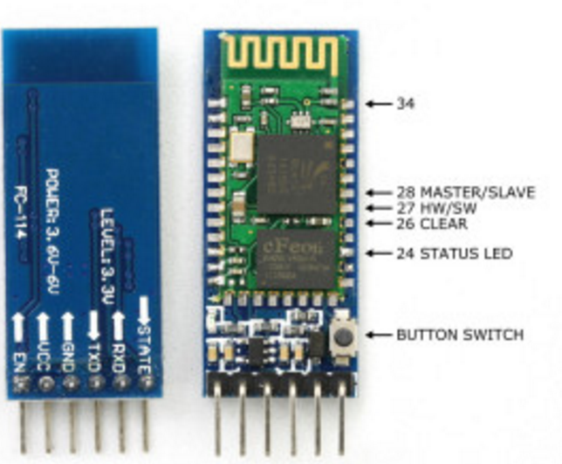

**Figure 13**: HC-06 Bluetooth Module Pin Out. <http://www.martyncurrey.com/hc-05-fc-114-and-hc-06-fc-114-first-look/>

5. Initialize simple Android Smartphone Application with necessary button interfaces.

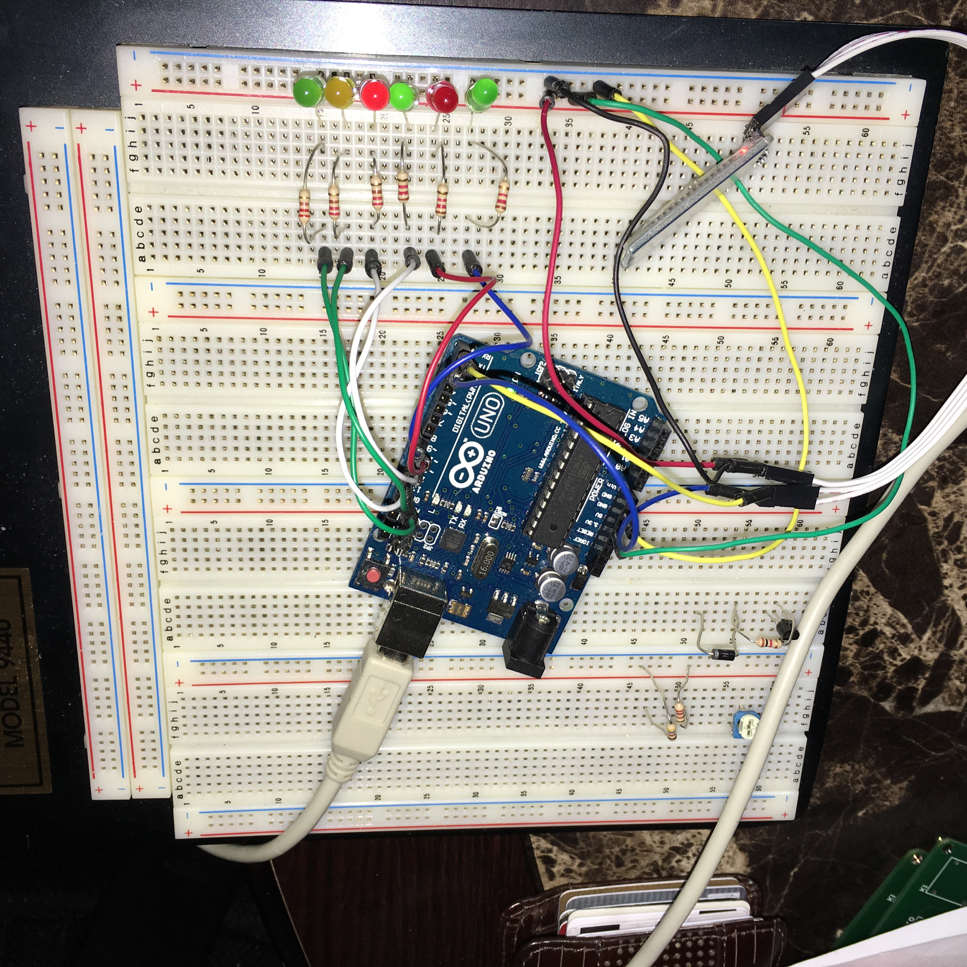**Test Data**:

**Figure 14**: Smartphone Interface Test Built Circuit (Arduino Mega, HC-06 BT Module, LEDs)

|  |  |  |
| --- | --- | --- |
|  | Is Button Present? | Does Button Work? |
| Physical Profile | Y/N | Y/N |
| Common Profile | Y/N | Y/N |
| Supplement Profile | Y/N | Y/N |
| Custom Profile | Y/N | Y/N |
| Pause | Y/N | Y/N |
| Resume | Y/N | Y/N |

**Table 5**: Gather Results from Smartphone Interface Test.

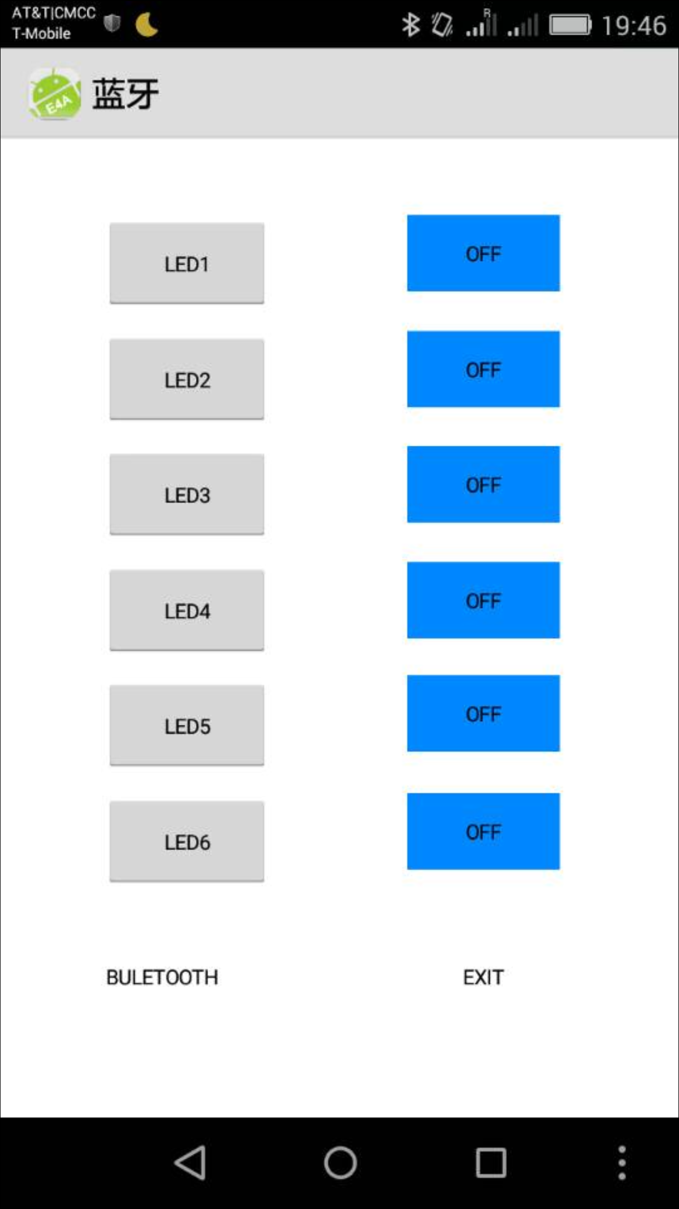

**Figure 15**: Simple Android Smartphone Application with six button (each representing: Physical, Common, Supplement, Custom, Start, and Pause).

**Conclusion**

From the data collected in Test 1, we have determined that the Acceptance Criteria was met. Our simple Android Smartphone application was set up to have six button. Each of the six buttons represented the Physical, Common, Supplement, and Custom brewing profile. The other two buttons left was for the Start and Pause button. After establishing wireless connection between the Smartphone Application and the Arduino UNO board, each button was pressed to see if they were able to turn on and off each of their assigned LED. Table 1 displays information gathered.

**Arduino Code:** Refer to Appendix F.

**Specification**: Test 2

**Test Nam**e: Water Level Test

**What is to be learned from this te**st: Can the prototype detect water level inside the herbal pot.

**Acceptance Criteria**: Comparing the initial temperature and the detected temperature. If the values did change, the test is successful. If the temperatures values did not change, the test has failed.

**Equipment List**:

* Arduino Uno
* USB Cable
* Liquid Crystal Display
* 10 kΩ Potentiometer
* DS18B20 Thermometer
* Green L.E.D
* 220 Ω Resistor (1)
* 4.7 kΩ Resistor (1)
* Wires

**Procedure**

1. Setup Arduino Program and include DallasTemperature and LiquidCrystal libraries.

2. Wire to +5 V and GND

3. Wire LCD pins to the Arduino Uno Board (refer to Figure 1):

- LCD RS Pin to digital pin 12

- LCD Enable Pin to digital pin 11

- LCD D4 pin to digital pin 5

- LCD D5 pin to digital pin 4

- LCD D6 pin to digital pin 3

- LCD D7 pin to digital pin 2

- 10 kΩ Potentiometer to pin 16

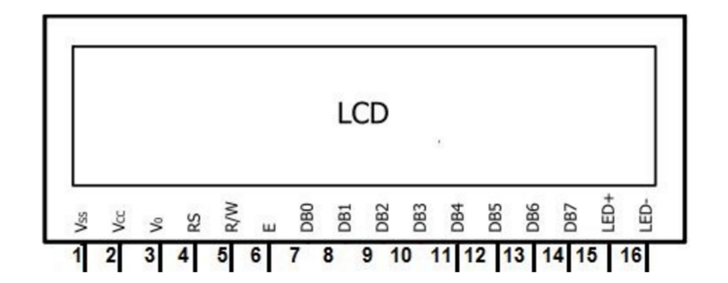

**Figure 16**: 20X4 LCD Pin Layout. (https://www.hackster.io/windows-iot/smartfaire-on-raspberry-pi-2-bda1dc)

4. Wire DS18B20 Thermometer according to Figure 2. Data line is the wire to digital pin 7 on the Arduino Uno.

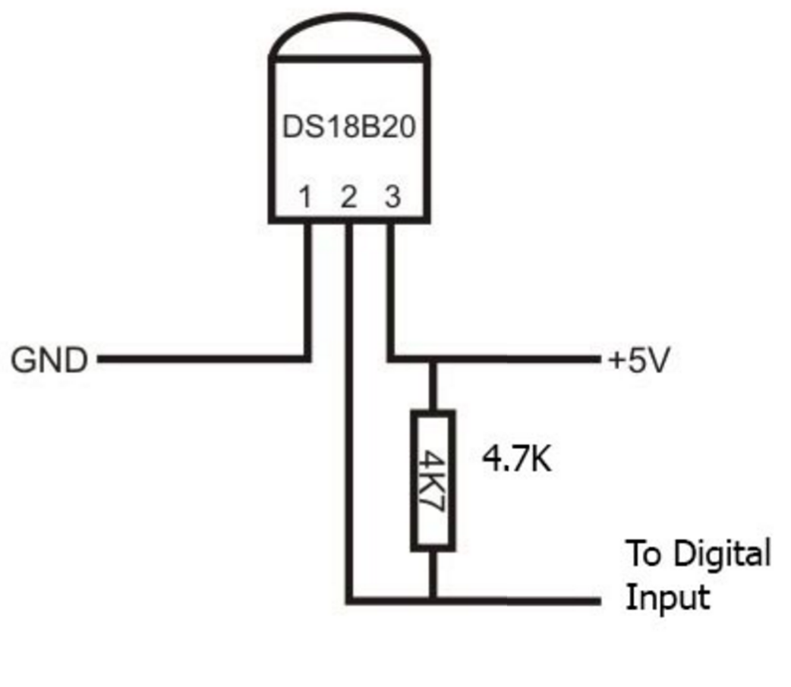

**Figure 17**: Wire Diagram of DS18B20.

<https://arduino-info.wikispaces.com/Brick-Temperature-DS18B20>

5. Wire 220 Ω Current Limit Resistor and Green L.E.D to pin 13 on the Arduino Uno.

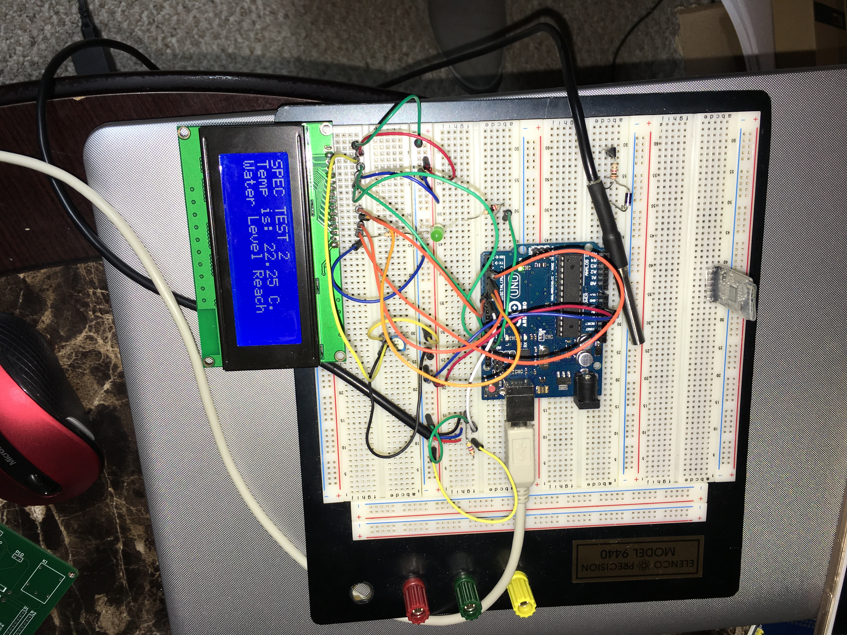**Test Data**:

**Figure 18**: Arduino Uno using a DS18B20 Transducer and Displaying Temperature Values on LCD.

Total height of the herbal pot (3.0 L) is 14.7 cm.



**Table 6**: Distance from Base of the Herbal Pot to Different Water Volume.



**Table 7**: Initial and Measured Temperature at Different Water Volume.

**Conclusion**

From the data collect in Test 2, we have determined that the Acceptance Criteria was met. At the initial of this test, several measurement were done to determine the water level height from the base of the herbal pot. With a measuring cup, different water volume were poured into the herbal pot. At each volume, a ruler was used to measure the height of the water level from the base, shown in Table 1. This information would serve in a later purpose for our prototype. Specifically for this test, we used the following heights: 6.6 cm and 2.8cm. These height were selected due to one of our primary specification. Table 2, presents the different temperature registered when initialized and when the water had reach a specific height. A noticeable difference in temperature between the initial measured temperature and when the water level reach the transducer.

**Arduino Code**: Refer to Appendix G.

**Specification**: Test 3

**Test Name**: Brewing Profile Test #1

**What is to be learned from this test**: Can the Automated Herbal Pot perform the Physical temperature profile.

**Acceptance Criteria**: If the LEDs does follow the pre-determined state of the LEDs, the test has passed, otherwise the test has failed.

**Equipment List**:

* Arduino MEGA
* 220 Ω Resistor (3)
* Green LED (1)
* Yellow LED (1)
* Red LED (1)
* HC-06 Bluetooth Module
* Android Smartphone Application

**Procedure**:

1. Include Wire library in Arduino Program.

2. Set Arduino MEGA digital pin (7 – 9) to Output

3. Connect 220 Ω Resistors and LEDs to each of the following digital pins in Procedure 2.

4. Wire HC-06 Bluetooth Module to each pin of the Arduino UNO:

- VCC to 5V

- GND to GND

- Rx to Tx

- Tx to Rx



**Figure 19**: HC-06 Bluetooth Module Pin Out. <http://www.martyncurrey.com/hc-05-fc-114-and-hc-06-fc-114-first-look/>

5. Initialize Android Smartphone Application.

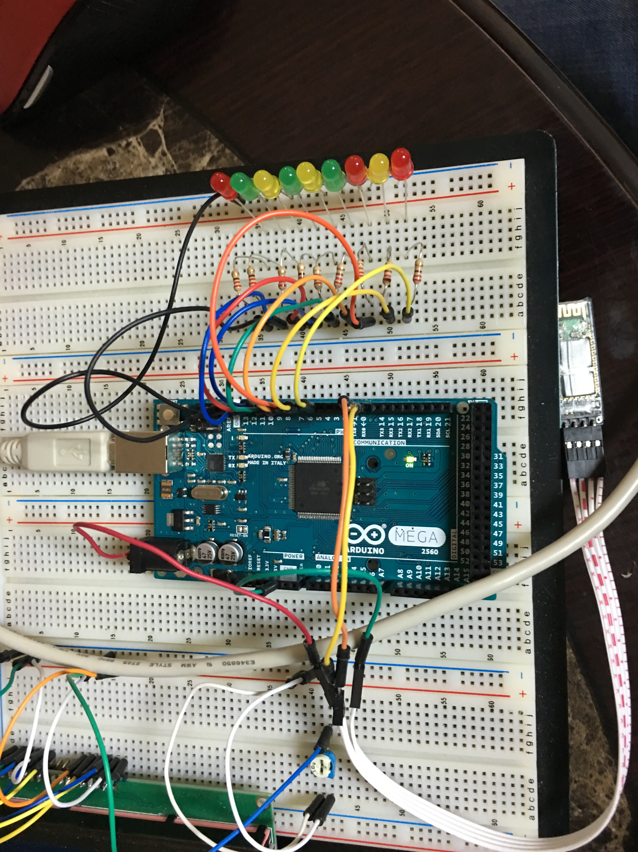**Test Data**:

**Figure 20**: Smartphone Interface Test Built Circuit (Arduino UNO, HC-06 BT Module, LEDs)



**Table 8**: Pre-determined Pattern for Physical Temperature Profile.

**Figure 21**: Observed LEDs State for Physical Temperature Profile.

**Conclusion**

From the data collected in Test 3, we have determined that the Acceptance Criteria was met. Several adjustments were made in order to speed the test. In our program, our counter was set that 2 seconds equals 1 minute in real time. As the program begin the Physical temperature profile, we observed 3 different LEDs. The Yellow LED symbolized when the temperature of the water inside the herbal pot has reached 100 °C. Also the Green LED for 80 °C and the RED LED for 50 °C. As seen in Table 2, our recorded observation of the on/off state of each LED did match the pre-determined on/off states of the LED, refer to Table 1.

**Arduino Code**: Refer to Appendix H.

**Specification**: Test 4

**Test Name**: Brewing Profile Test #2

**What is to be learned from this test**: Can the Automated Herbal Pot perform the Common temperature profile.

**Acceptance Criteria**: If the LEDs does follow the pre-determined state of the LEDs, the test has passed, otherwise the test has failed.

**Equipment List**:

* Arduino MEGA
* 220 Ω Resistor (3)
* Green LED (1)
* Yellow LED (1)
* Red LED (1)
* HC-06 Bluetooth Module
* Android Smartphone Application

**Procedure**:

1. Include Wire library in Arduino Program.

2. Set Arduino MEGA digital pin (7 – 9) to Output

3. Connect 220 Ω Resistors and LEDs to each of the following digital pins in Procedure 2.

4. Wire HC-06 Bluetooth Module to each pin of the Arduino UNO:

- VCC to 5V

- GND to GND

- Rx to Tx

- Tx to Rx



**Figure 22**: HC-06 Bluetooth Module Pin Out. <http://www.martyncurrey.com/hc-05-fc-114-and-hc-06-fc-114-first-look/>

5. Initialize Android Smartphone Application.

**Test Data**:

**Figure 23**: Smartphone Interface Test Built Circuit (Arduino UNO, HC-06 BT Module, LEDs)



**Table 9**: Pre-determined Pattern for Common Temperature Profile.

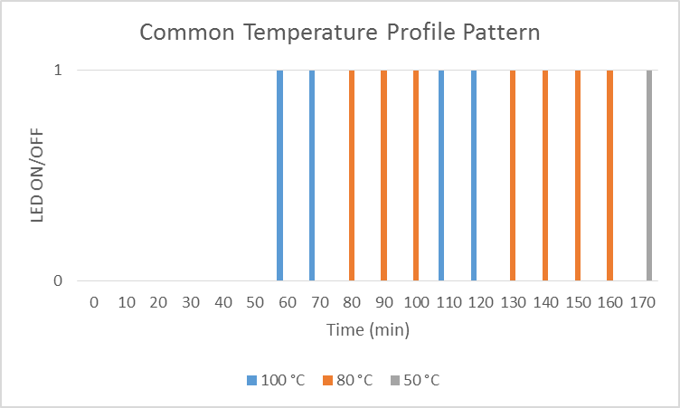

**Figure 24**: Observed LEDs State for Common Temperature Profile.

**Conclusion**

From the data collected in Test 3, we have determined that the Acceptance Criteria was met. Several adjustments were made in order to speed the test. In our program, our counter was set that 2 seconds equals 1 minute in real time. As the program begin the Common temperature profile, we observed 3 different LEDs. The Yellow LED symbolized when the temperature of the water inside the herbal pot has reached 100 °C. Also the Green LED for 80 °C and the RED LED for 50 °C. As seen in Table 2, our recorded observation of the on/off state of each LED did match the pre-determined on/off states of the LED, refer to Table 1.

**Arduino Code**: Refer to Appendix H.

**Specification**: Test 5

**Test Name**: Brewing Profile Test #3

**What is to be learned from this test**: Can the Automated Herbal Pot perform the Supplement temperature profile.

**Acceptance Criteria**: If the LEDs does follow the pre-determined state of the LEDs, the test has passed, otherwise the test has failed.

**Equipment List**:

* Arduino MEGA
* 220 Ω Resistor (3)
* Green LED (1)
* Yellow LED (1)
* Red LED (1)
* HC-06 Bluetooth Module
* Android Smartphone Application

**Procedure**:

1. Include Wire library in Arduino Program.

2. Set Arduino MEGA digital pin (7 – 9) to Output

3. Connect 220 Ω Resistors and LEDs to each of the following digital pins in Procedure 2.

4. Wire HC-06 Bluetooth Module to each pin of the Arduino UNO:

- VCC to 5V

- GND to GND

- Rx to Tx

- Tx to Rx



**Figure 25**: HC-06 Bluetooth Module Pin Out. <http://www.martyncurrey.com/hc-05-fc-114-and-hc-06-fc-114-first-look/>

5. Initialize Android Smartphone Application.

**Test Data**:

**Figure 26**: Smartphone Interface Test Built Circuit (Arduino UNO, HC-06 BT Module, LEDs)



**Table 10**: Pre-determined Pattern for Supplement Temperature Profile.

**Figure 27**: Observed LEDs State for Supplement Temperature Profile.

**Conclusion**

From the data collected in Test 3, we have determined that the Acceptance Criteria was met. Several adjustments were made in order to speed the test. In our program, our counter was set that 2 seconds equals 1 minute in real time. As the program begin the Supplement temperature profile, we observed 3 different LEDs. The Yellow LED symbolized when the temperature of the water inside the herbal pot has reached 100 °C. Also the Green LED for 80 °C and the RED LED for 50 °C. As seen in Table 2, our recorded observation of the on/off state of each LED did match the pre-determined on/off states of the LED, refer to Table 1.

**Arduino Code**: Refer to Appendix H.

**Specification**: Test 6

**Test Name**: Brewing Profile Test #4

**What is to be learned from this test**: Can the Automated Herbal Pot perform the Custom temperature profile.

**Acceptance Criteria**: If the LEDs does follow the pre-determined state of the LEDs, the test has passed, otherwise the test has failed.

**Equipment List**:

* Arduino MEGA
* 220 Ω Resistor (3)
* Green LED (1)
* Yellow LED (1)
* Red LED (1)
* HC-06 Bluetooth Module
* Android Smartphone Application

**Procedure**:

1. Include Wire library in Arduino Program.

2. Set Arduino MEGA digital pin (7 – 9) to Output

3. Connect 220 Ω Resistors and LEDs to each of the following digital pins in Procedure 2.

4. Wire HC-06 Bluetooth Module to each pin of the Arduino UNO:

- VCC to 5V

- GND to GND

- Rx to Tx

- Tx to Rx



**Figure 28**: HC-06 Bluetooth Module Pin Out. <http://www.martyncurrey.com/hc-05-fc-114-and-hc-06-fc-114-first-look/>

5. Initialize Android Smartphone Application.

**Test Data**:

**Figure 29**: Smartphone Interface Test Built Circuit (Arduino UNO, HC-06 BT Module, LEDs)



**Table 11**: Pre-determined Pattern for Custom Temperature Profile.

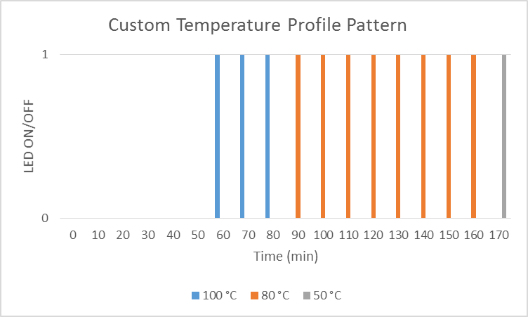

**Figure 30**: Observed LEDs State for Custom Temperature Profile.

**Conclusion**

From the data collected in Test 3, we have determined that the Acceptance Criteria was met. Several adjustments were made in order to speed the test. In our program, our counter was set that 2 seconds equals 1 minute in real time. As the program begin the Custom temperature profile, we observed 3 different LEDs. The Yellow LED symbolized when the temperature of the water inside the herbal pot has reached 100 °C. Also the Green LED for 80 °C and the RED LED for 50 °C. As seen in Table 2, our recorded observation of the on/off state of each LED did match the pre-determined on/off states of the LED, refer to Figure 31.

**Arduino Code**: Refer to Appendix H.

**Specification**: Test 7

**Test Name**: Heating Element Test

**What is to be learned from this test**: Can the prototype be able to turn on/off the heating element at a determined temperature.

**Acceptance Criteria**: The test is successful if the LED is turned on at 25 °C and also if the LED is turned off at 100 °C.

**Equipment List**:

* Arduino MEGA
* 220 Ω Resistor (1)
* Red LED (1)
* 2N2222 Transistor (1)
* 1N4001 Diode (1)
* 20x4 LCD
* DS18B20 Thermometer (1)
* JQC-3F Relay
* Heating Element

**Procedure**:

1. Include OneWIre, DallasTemperature, and LiquidCrystal library in Arduino Program.

2. Wire the circuit as shown in Figure 1.

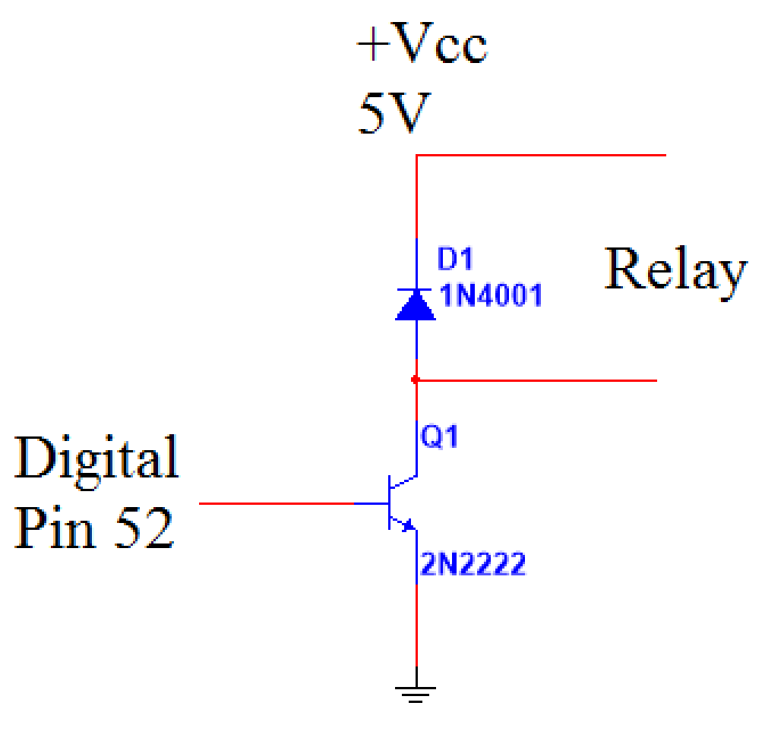

**Figure 31**: Diode and Transistor Circuit Diagram.

3. Set Arduino MEGA digital pin 7 to Output.

4. Wire 220 Ω current limit resistor and Red LED to digital pin 7.

5. Wire LCD pins to the Arduino Uno Board (refer to Figure 1):

- LCD RS Pin to digital pin 24

- LCD Enable Pin to digital pin 25

- LCD D4 pin to digital pin 29

- LCD D5 pin to digital pin 28

- LCD D6 pin to digital pin 27

- LCD D7 pin to digital pin 26

- 10 kΩ Potentiometer to pin 16



**Figure 32**: 20X4 LCD Pin Layout. (<https://www.hackster.io/windows-iot/smartfaire-on-raspberry-pi-2-bda1dc>)

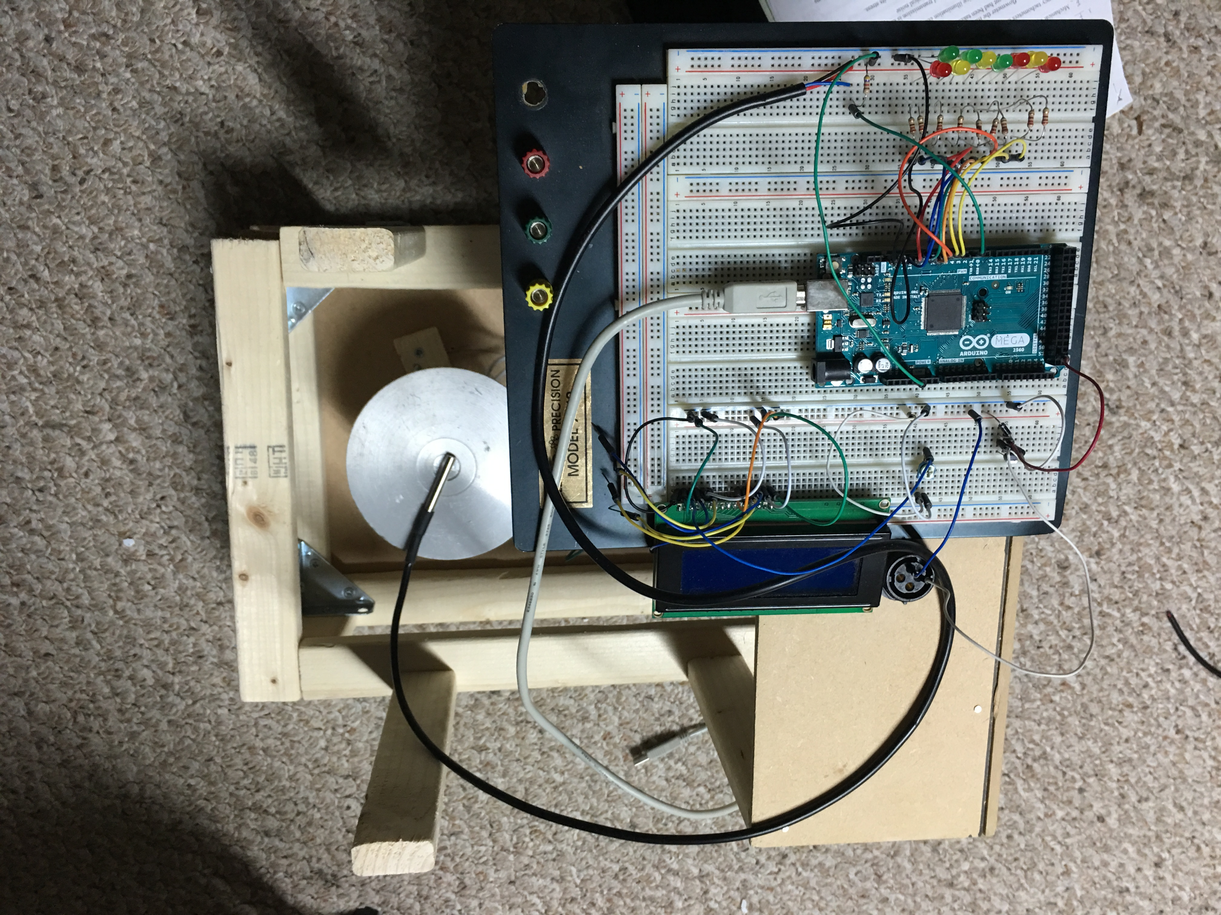**Test Data**:

**Figure 33**: Arduino MEGA using a DS18B20 Transducer and Displaying Temperature Values on LCD.



**Table 12**: Results from Test Display Current Temperature and State of LED.

**Conclusion**

From the data collected in Test 7, we have determined that the Acceptance Criteria was met. As the Arduino program initialized, the heating element begins to heat up. The led should turn on when the temperature reaches 25 °C. As it continues to heat up and reaches 100 °C, the LED turns off. This result can be displayed in Table 1.

**Arduino Code**: Refer to Appendix I.

**Appendix A**

Gantt Charts













**Appendix B**

**Figure 34:** Temperature vs Time Brewing Profile

**Figure 35:** Temperature vs Time Brewing Profile

**Figure 36:** Temperature vs Time Brewing Profile

**Figure 37:** Temperature vs Time Brewing Profile

**Appendix C**

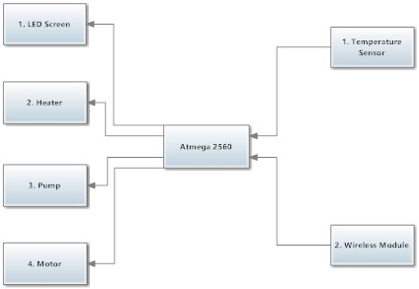

**Figure 38:** Smart Brew Input and Output Block Diagram.

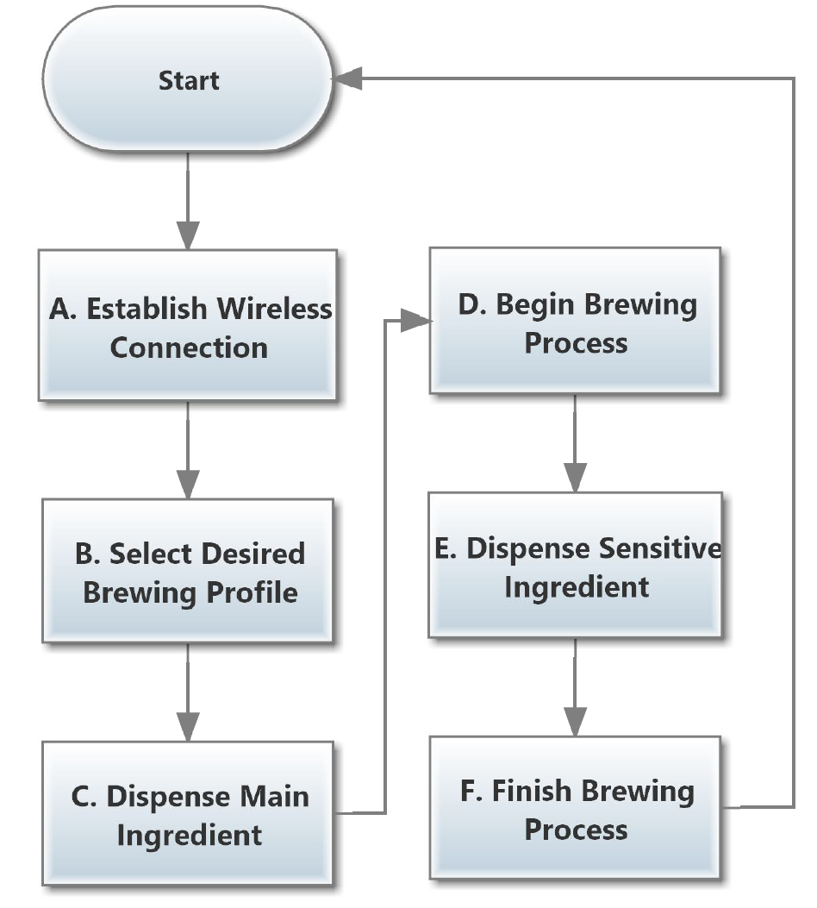

**Figure 39**: Smart Brew Simple Flow Chart.



**Figure 40:** Android Application Flowchart.

**Appendix D**

//these are library which used in below program

#include <Wire.h>

#include <OneWire.h>

#include <DallasTemperature.h>

#include <LiquidCrystal.h>

//set up all global variable and const number

const int EN1 = 21;

const int EN2 = 20;

const int MR = 19;

const int MB = 18;

const int PUMP = 23;

const int HEATER = 22;

const int SW1 = 42;

const int SW2 = 43;

const int SW3 = 44;

const int SW4 = 45;

float a;

float b;

float c;

float tempture1;

int p;

int water = 0;

int buttonState = 0;

bool check1 = false;

bool check2 = false;

bool check3 = false;

bool motor = false;

bool pu = false;

bool start = false;

bool pause = false;

bool restart = false;

bool highheat = false;

bool slowheat = false;

bool keepheat = false;

bool motor2 = false;

bool strong = false;

bool motormove = false;

bool heat = false;

// set up LCD screen

LiquidCrystal lcd(24, 25, 29, 28, 27, 26);

// set up RTD sensor

#define ONE_WIRE_BUS 30

OneWire oneWire (ONE_WIRE_BUS); // on digital pin 30

DallasTemperature sensors(&oneWire);

DeviceAddress RTD1 = {0x28, 0xFF, 0xE3, 0x0E, 0x91, 0x15, 0x01, 0x07};

DeviceAddress RTD2 = {0x28, 0xFF, 0x50, 0x8D, 0x65, 0x15, 0x02, 0xA6};

DeviceAddress RTD3 = {0x28, 0xFF, 0xAD, 0x5E, 0x90, 0x15, 0x03, 0x83};

//start the program setup

void setup() {

pinMode(PUMP, OUTPUT);

digitalWrite(PUMP, HIGH);

Serial.begin(9600);

lcd.begin(20, 4);

sensors.begin();

sensors.setResolution(RTD1, 10);

sensors.setResolution(RTD2, 10);

sensors.setResolution(RTD3, 10);

pinMode(EN1, OUTPUT);

pinMode(EN2, OUTPUT);

pinMode(MR, OUTPUT);

pinMode(MB, OUTPUT);

pinMode(HEATER, OUTPUT);

pinMode(SW1,INPUT);

pinMode(SW2,INPUT);

pinMode(SW3,INPUT);

pinMode(SW4,INPUT);

lcd.setCursor(0, 1);

lcd.print("Welcome to Smartbrew");

}

// the program main loop, this loop mainly tests the subroutine can be used or not by Boolean variable, then decide to go to which subroutine

void loop() {

if (pause == true){

lcd.clear();

lcd.setCursor(7, 1);

lcd.print("Pause");

PauseSET();

}

if (motor == true){

lcd.clear();

lcd.setCursor(2, 1);

lcd.print("Loading Ingredient");

MOTORstart();

lcd.clear();

lcd.setCursor(3, 1);

lcd.print("Finish Loading");

}

if (pu == true){

lcd.clear();

lcd.setCursor(3, 1);

lcd.print("Filling Water");

PUMPstart();

lcd.clear();

lcd.setCursor(4, 1);

lcd.print("Water Filled");

}

if (highheat == true){

lcd.clear();

lcd.setCursor(5, 1);

lcd.print("High Heat");

HighHeater();

}

if (slowheat == true){

lcd.clear();

lcd.setCursor(4, 1);

lcd.print("Medium Heat");

SlowHeater();

}

if (keepheat == true){

lcd.clear();

lcd.setCursor(5, 1);

lcd.print("Keep Warm");

KeepHeater();

}

if (motor2 == true) {

MOTOR2start();

}

if (restart == true) {

RestartSET();

}

recive();

}

//This is the received subroutine, it mainly receives data from Bluetooth and changes the global Boolean variable to open or close the other subroutine in the main loop

void recive(){

while (Serial.available() > 0) {

p = Serial.parseInt();

if (Serial.read() == 'X') {

switch (p) {

case 116:

if (motormove == false){

if (motor == false){

motor = !motor;

}

if (pu == false){

pu = !pu;

}

if (strong == false) {

strong = !strong;

}

}

if (start == false){

start = !start;

}

break;

case 117:

if (motormove == false){

if (motor == false){

motor = !motor;

}

if (pu == false){

pu = !pu;

}

}

if (start == false){

start = !start;

}

break;

case 118:

if (pause == false){

pause = !pause;

}

break;

case 119:

if (restart == false){

restart = !restart;

}

if (slowheat == true){

slowheat = !slowheat;

}

if (highheat == true){

highheat = !highheat;

}

if (keepheat == true){

keepheat = !keepheat;

}

break;

case 120:

if (highheat == false){

highheat = !highheat;

}

if (slowheat == true){

slowheat = !slowheat;

}

break;

case 121:

if (slowheat == false){

slowheat = !slowheat;

}

if (highheat == true){

highheat = !highheat;

}

break;

case 122:

if (keepheat == false){

keepheat = !keepheat;

}

if (slowheat == true){

slowheat = !slowheat;

}

if (highheat == true){

highheat = !highheat;

}

break;

case 130:

if (motor2 == false){

motor2 = !motor2;

}

break;

default:

break;

}

}

}

}

//this is the primary ingredient subroutine, which controls the primary ingredient cart

void MOTORstart(){

digitalWrite(EN1, HIGH);

digitalWrite(MR, HIGH);

buttonState = digitalRead(SW1);

while(buttonState == LOW){

digitalWrite(MR, HIGH);

buttonState = digitalRead(SW1);

}

digitalWrite(MR, LOW);

delay(3000);

digitalWrite(MB, HIGH);

buttonState = digitalRead(SW2);

while(buttonState == LOW){

digitalWrite(MB, HIGH);

buttonState = digitalRead(SW2);

}

digitalWrite(MB, LOW);

digitalWrite(EN1, LOW);

motormove = !motormove;

motor = !motor;

Serial.println(151);

}

void MOTOR2start(){

digitalWrite(EN2, HIGH);

digitalWrite(MR, HIGH);

buttonState = digitalRead(SW3);

while(buttonState == LOW){

digitalWrite(MR, HIGH);

buttonState = digitalRead(SW3);

}

digitalWrite(MR, LOW);

delay(3000);

digitalWrite(MB, HIGH);

buttonState = digitalRead(SW4);

while(buttonState == LOW){

digitalWrite(MB, HIGH);

buttonState = digitalRead(SW4);

}

digitalWrite(MB, LOW);

digitalWrite(EN2, LOW);

motor2 = !motor2;

}

//this is the pump subroutine which controls the pump to open/close

void PUMPstart(){

digitalWrite(PUMP, LOW);

float temp;

if (strong == true){

sensors.requestTemperatures();

if (check1 == false) {

a = sensors.getTempC(RTD1);

check1 = !check1;

}

sensors.requestTemperatures();

temp = sensors.getTempC(RTD1);

while ((temp > (a - 0.5)) && (temp < (a + 0.5))){

sensors.requestTemperatures();

temp = sensors.getTempC(RTD1);

}

sensors.requestTemperatures();

if (check2 == false) {

b = sensors.getTempC(RTD2);

check2 = !check2;

}

sensors.requestTemperatures();

temp = sensors.getTempC(RTD2);

while ((temp > (b - 0.5)) && (temp < (b + 0.5))){

sensors.requestTemperatures();

temp = sensors.getTempC(RTD2);

}

check1 = !check1;

check2 = !check2;

}

else{

sensors.requestTemperatures();

if (check1 == false) {

a = sensors.getTempC(RTD1);

check1 = !check1;

}

sensors.requestTemperatures();

temp = sensors.getTempC(RTD1);

while ((temp > (a - 0.5)) && (temp < (a + 0.5))){

sensors.requestTemperatures();

temp = sensors.getTempC(RTD1);

}

sensors.requestTemperatures();

if (check3 == false) {

c = sensors.getTempC(RTD3);

check3 = !check3;

}

sensors.requestTemperatures();

temp = sensors.getTempC(RTD3);

while ((temp > (c - 0.5)) && (temp < (c + 0.5))){

sensors.requestTemperatures();

temp = sensors.getTempC(RTD3);

}

check1 = !check1;

check3 = !check3;

}

digitalWrite(PUMP, HIGH);

if (pu == true) {

Serial.println(152);

pu = !pu;

}

}

//this is the high heat subroutine which is to control the heating element to keep around 90 C

void HighHeater() {

sensors.requestTemperatures();

tempture1 = sensors.getTempC(RTD1);

Serial.println(tempture1);

lcd.setCursor(3, 2);

lcd.print("Temperature is");

lcd.setCursor(7, 3);

lcd.print(tempture1);

lcd.print(" C");

delay(1000);

if ((tempture1 < 89) && (heat == false)){

digitalWrite(HEATER, HIGH);

heat = !heat;

}

else if (tempture1 > 89) {

digitalWrite(HEATER, LOW);

if (heat == true){

heat = !heat;

}

water = water + 1;

}

if ((water > 0) && (tempture1 < 79)){

PUMPstart();

}

}

//this is the slow heat subroutine which is to control the heating element to keep around 80 C

void SlowHeater() {

sensors.requestTemperatures();

tempture1 = sensors.getTempC(RTD1);

Serial.println(tempture1);

lcd.setCursor(3, 2);

lcd.print("Temperature is");

lcd.setCursor(7, 3);

lcd.print(tempture1);

lcd.print(" C");

delay(1000);

if ((tempture1 < 80) && (heat == false)){

digitalWrite(HEATER, HIGH);

heat = !heat;

}

else if (tempture1 > 81) {

digitalWrite(HEATER, LOW);

if (heat == true){

heat = !heat;

}

water = water + 1;

}

if ((water > 0) && (tempture1 < 71)){

PUMPstart();

}

}

//this is the keep warm subroutine which is to control the heating element to keep around 50 C

void KeepHeater(){

Serial.println(154);

sensors.requestTemperatures();

tempture1 = sensors.getTempC(RTD1);

lcd.setCursor(3, 2);

lcd.print("Temperature is");

lcd.setCursor(7, 3);

lcd.print(tempture1);

lcd.print(" C");

delay(1000);

if ((tempture1 <49) && (heat == false)){

digitalWrite(HEATER, HIGH);

heat = !heat;

}

else if (tempture1 > 50) {

digitalWrite(HEATER, LOW);

if (heat == true){

heat = !heat;

}

}

}

//this is the Pause subroutine when it is pressed, all process are paused.

void PauseSET() {

if (start == true) {

start = !start;

}

digitalWrite(HEATER, LOW);

while (start == false){

recive();

}

pause = !pause;

if (heat == true){

heat = !heat;

}

}

//This is restart subroutine.

void RestartSET() {

restart = !restart;

a = 0;

b = 0;

c = 0;

tempture1 = 0;

p = 0;

water = 0;

buttonState = 0;

digitalWrite(HEATER, LOW);

if (strong == true){

strong = !strong;

}

if (motormove == true){

motormove = !motormove;

}

if (heat == true){

heat = !heat;

}

if (start == true){

start = !start;

}

lcd.clear();

lcd.setCursor(0, 1);

lcd.print("Welcome to Smartbrew");

}

**Appendix E**

Boolean pump

Boolean motor

Boolean motor2

Boolean Afterrelease

Boolean completion

Boolean start

Boolean pause

Boolean Restart

Boolean one

Boolean two

Boolean three

Boolean Four

Boolean Lowwater

Boolean heatingpause

Int input1

Int input2

Int input3

Int input4

Int Totaltime

Int temperature

String return

Int count

Int add1

Int add2

Int add3

Int Secondinverted

Main event mainwindow.created ()

Pump = false

Motor = false

Motor 2 = false

Afterrelease = false

completion = False

Start = False

Pause = False

Heatingpause = false

Restart = false

one = false

Two = false

Three = false

Four = false

Lowwater = false

Input1 = 0

Input2 = 0

Input3 = 0

Input4 = 0

Totaltime = 0

Temperature = 0

Count = 0

add1 = 0

add2 = 0

add3 = 0

Secondinverted = 0

     return = ""

If Bluetooth1 is turned on () = false then

Bluetooth 1. TurnonBluetooth ()

End If

End Event

Event mainwindow. started (String startupparameter)

If the startupparameter = "wake up" the

SystemSetup1. Alwayskeepscreen ()

SystemSetup1. screenunlock ()

End If

End Event

Event Bluetooth 1. Bluetooth is set up (Int setto)

Switch setto

Branch 1

Messagebox ( "Bluetooth already open")

Bluetooth1. canfound()

Branch 2

Messagebox ( "message", "Bluetooth not open, Exit", "ok")

Me.close ()

Branch 3

Messagebox ( "Bluetooth avaliable")

Branch 4

Messagebox ( "message", "Bluetooth not avaliable, Exit", "ok")

Me.close ()

End Switch

Bluetooth1. Setmode (1)

End Event

event button1.clicked ()

Bluetooth1. Searchdevices ()

Messagebox ( "Searching")

End Event

event Bluetooth1. devicediscovery (String devicename, String address, Boolean paired)

listbox1. Visible= True

listbox1.items.Add (device name & "_" & Device Address & "_" & paired) '

End Event

event listbox1.clicked (Int index)

String deviceinformation

String Textarray()

String deviceaddress

deviceinformation = listbox1.item.read(index)

Textarray = split (deviceinformation, "_")

deviceaddress = Textarray (1)

Messagebox (device address)

Bluetooth1.Connectdevice (deviceaddress)

Messagebox ( "Connecting")

End Event

event Bluetooth1. connection (Boolean result, String devicename, String deviceaddress, Int mode)

If result = true

Listbox1. visible = false

Mainwindow.text = "Connect:" & Device Name

messagebox ( "Connect Successful")

Button6. Visible = true

Button7. Visible = true

Button8. Visible = true

Button9. Visible = true

else

messagebox ( "Connect error")

End If

End Event

Event Bluetooth1.receive (byte data(), String devicename, String deviceaddress)

return = return & bytetoString (data, "UTF8")

If text.readright (return, 1) = "\ n"

Switch text.readleft(return, lengh(return)-2)

Branch "151"

Motor = true

mainwindow. text = "MOTOR OVER"

Branch "152"

Pump = true

mainwindow. text = "PUMP OVER"

Branch "154"

completion = true

Others

temperature = text.readleft (return, lengh(return)-2)

End Switch

If temperature> 100

temperature = 100

End If

return = ""

End If

End Event

event button2.clicked ()

Bluetooth1.send (Stringtobyte ("119X", "UTF8"))

Bluetooth 1. Disconnect ()

Me.close ()

End Event

event button9.clicked ()

Input1 = 0

Input2 = 0

Input3 = 0

Input4 = 0

button6.visible = false

button7.visible = false

button8.visible = false

button9.visible = false

button3.visible = true

button5.visible = true

lable3.visible = true

lable4.visible = true

lable5.visible = true

lable6.visible = true

textbox1.visible = true

textbox2.visible = true

textbox3.visible = true

textbox4.visible = true

selectbox1.visible = true

selectbox2.visible = true

lable1.visible = true

lable2.visible = true

End Event

event button8.clicked ()

Input1 = 30

Input2 = 120

Input3 = 0

Input4 = 0

add1 = 59 + input1

add2 = add1 + Input2

add3 = add2 + Input3

button6.visible = false

button7.visible = false

button8.visible = false

button9.visible = false

button3.visible = true

button5.visible = true

selectbox1.visible = true

selectbox2.visible = true

lable1.visible = true

lable2.visible = true

End Event

event button7.clicked ()

Input1 = 20

Input2 = 30

Input3 = 15

Input4 = 60

add1 = 59 + input1

add2 = add1 + Input2

add3 = add2 + Input3

button6.visible = false

button7.visible = false

button8.visible = false

button9.visible = false

button3.visible = true

button5.visible = true

selectbox1.visible = true

selectbox2.visible = true

lable1.visible = true

lable2.visible = true

End Event

event button6.clicked ()

Input1 = 20

Input2 = 90

Input3 = 0

Input4 = 0

add1 = 59 + input1

add2 = add1 + Input2

add3 = add2 + Input3

button6.visible = false

button7.visible = false

button8.visible = false

button9.visible = false

button3.visible = true

button5.visible = true

selectbox1.visible = true

selectbox2.visible = true

lable1.visible = true

lable2.visible = true

End Event

event button3.clicked ()

If textbox1.visible = true

If textbox1.text = 0

messagebox( "Please, enter the time in first high heat")

else

If textbox2.text = 0

messagebox( "Please, enter the time in first slow heat")

else

If textbox3.text = 0

Input2 = Input2 + Input4

Input4 = 0

clock2. clockcycle = 1

Start = True

add1 = 59 + input1

add2 = add1 + Input2

add3 = add2 + Input3

Totaltime = add3 + input4

Secondinverted = Totaltime -10

textbox1.visible = false

textbox2.visible = false

textbox3.visible = false

textbox4.visible = false

lable3.visible = false

lable4.visible = false

lable5.visible = false

lable6.visible = false

button3.visible = false

button2.visible = false

Systemalarm1. Alarmcycle (1, 1000, "wake up")

If lowwater = true

Bluetooth1.send (stringtobyte ( "116X", "UTF8"))

else

Bluetooth1.send (stringtobyte ( "117X", "UTF8"))

End If

else

clock2. clockcycle = 1

Start = True

add1 = 59 + input1

add2 = add1 + Input2

add3 = add2 + Input3

Totaltime = add3 + input4

Secondinverted = Totaltime -10

textbox1.visible = false

textbox2.visible = false

textbox3.visible = false

textbox4.visible = false

lable3.visible = false

lable4.visible = false

lable5.visible = false

lable6.visible = false

button3.visible = false

button2.visible = false

Systemalarm1. Alarmcycle (1, 1000, "wake up")

If lowwater = true

Bluetooth1.send (stringtobyte ( "116X", "UTF8"))

else

Bluetooth1.send (stringtobyte ( "117X", "UTF8"))

End If

End If

End If

End If

else

If start = false

clock2. clockcycle = 1

Start = True

add1 = 59 + input1

add2 = add1 + Input2

add3 = add2 + Input3

Totaltime = add3 + input4

Secondinverted = Totaltime -10

button3.visible = false

button2.visible = false

Systemalarm1. Alarmcycle (1, 1000, "wake up")

If lowwater = true

Bluetooth1.send (stringtobyte ( "116X", "UTF8"))

else

Bluetooth1.send (stringtobyte ( "117X", "UTF8"))

End If

else

button3.visible = false

button4.visible = true

Pause = False

Heatingpause = false

If lowwater = true

Bluetooth1.send (stringtobyte ( "116X", "UTF8"))

else

Bluetooth1.send (stringtobyte ( "117X", "UTF8"))

End If

End If

End If

End Event

event button4.clicked ()

Bluetooth1.send (stringtobyte ( "118X", "UTF8"))

Pause = true

Heatingpause = true

Clock1. clockcycle = 0

button3.visible = true

button4.visible = false

End Event

event button5.clicked ()

Bluetooth1.send (stringtobyte ( "119X", "UTF8"))

Pump = false

Motor = false

Motor 2 = false

Afterrelease = false

completion = False

Start = False

Pause = False

Heatingpause = false

Restart = false

one = false

Two = false

Three = false

Four = false

Lowwater = false

Input1 = 0

Input2 = 0

Input3 = 0

Input4 = 0

Totaltime = 0

Temperature = 0

Count = 0

add1 = 0

add2 = 0

add3 = 0

Secondinverted = 0

     return = ""

button1.visible = true

button2.visible = true

button3.visible = false

button4.visible = false

button5.visible = false

button6.visible = true

button6.useable = true

button7.visible = true

button7.useable = true

button8.visible = true

button8.useable = true

button9.visible = true

button9.useable = true

button10.visible = false

selectbox1.visible = false

selectbox2.visible = false

lable1.visible = false

lable2.visible = false

lable3.visible = false

lable4.visible = false

lable5.visible = false

lable6.visible = false

textbox1.visible = false

textbox2.visible = false

textbox3.visible = false

textbox4.visible = false

textbox1.text = ( "0")

textbox2.text = ( "0")

textbox3.text = ( "0")

textbox4.text = ( "0")

listbox1.items.clear()

lable2.text = ( "Not start to heat")

lable1.text = ( "0 mins")

Mainwindow.text = ( "SELECT THE BREW PROFILE")

systemalarm1. Destruction (1)

Clock2. clockcycle = 0

Clock1. clockcycle = 0

End Event

event button10.clicked ()

systemalarm1. Destruction (1)

Clock2. clockcycle = 0

Bluetooth1.send (stringtobyte ( "119X", "UTF8"))

Bluetooth1. Disconnect ()

     Me.close()

End Event

event clock1.clockcycle ()

Count = count + 1

lable1.text = (Integertostring(count) & "mins")

End Event

event clock2.clockcycle ()

If count > 59

lable2.text = (Integer to text (temperature) & "C")

else

lable2.text = ( "Not start to heat")

End If

If count > Secondinverted

If motor2 = true

Bluetooth1.send (stringtobyte ( "130X", "UTF8"))

End If

End If

If pump = true

If pause = false

Button 4. visible = true

Button 5. visible = true

If Clock1. clockcycle = 0

Clock1. clockcycle = 6000

End If

else

Button 4. visible = false

If Clock1. clockcycle = 6000

Clock1. clockcycle = 0

End If

End If

End If

If input3 = 0

If count > Totaltime

if three= False

Bluetooth1.send (stringtobyte ( "122X", "UTF8"))

Clock1. clockcycle = 0

Count = 0

Pause = true

mainwindow. Text = "FINISH"

completion = true

Three = true

End If

Else

If count > add1

If Two = false

Bluetooth1.send (stringtobyte ( "121X", "UTF8"))

Clock1. clockcycle = 0

Pause = true

mainwindow. Text = "HEAT TO SLOW HEAT"

Two = true

End If

Else

If count > 59

if one = false

Bluetooth1.send (stringtobyte ( "120X", "UTF8"))

Clock1. clockcycle = 0

Pause = true

mainwindow. Text = "HEAT TO HIGH HEAT"

one = true

End If

End If

End If

End If

else

If count > Totaltime

If completion = False

Bluetooth1.send (stringtobyte ( "122X", "UTF8"))

Clock1. clockcycle = 0

Count = 0

Pause = true

mainwindow. Text = "FINISH"

completion = true

End If

else

If count > add3

If Four = false

Bluetooth1.send (stringtobyte ( "121X", "UTF8"))

Clock1. clockcycle = 0

Pause = true

mainwindow. Text = "HEAT TO SLOW HEAT"

Four = true

End If

Else

If count > add2

if Three = false

Bluetooth1.send (stringtobyte ( "120X", "UTF8"))

Clock1. clockcycle = 0

Pause = true

mainwindow. Text = "HEAT TO HIGH HEAT"

Three = true

End If

Else

If count > add1

If Four = false

Bluetooth1.send (stringtobyte ( "121X", "UTF8"))

Clock1. clockcycle = 0

Pause = true

mainwindow. Text = "HEAT TO SLOW HEAT"

Two = true

End If

else

if one = false

Bluetooth1.send (stringtobyte ( "120X", "UTF8"))

Clock1. clockcycle = 0

Pause = true

mainwindow. Text = "HEAT TO HIGH HEAT"

one = true

End If

End If

End If

End If

End If

End If

If temperature > 88 and heatingpause = false

If one = true and Two = false

If Clock1. clockcycle = 0

Clock1. clockcycle = 6000

Pause = False

End If

End If

End If

If temperature < 82 and heatingpause = false

If Two = true and Three = false

If Clock1. clockcycle = 0

Clock1. clockcycle = 6000

Pause = False

End If

End If

End If

If temperature > 88 and heatingpause = false

If Three = true and Four = false

If Clock1. clockcycle = 0

Clock1. clockcycle = 6000

Pause = False

End If

End If

End If

If temperature < 82 and heatingpause = false

If Four = true

If Clock1. clockcycle = 0

Clock1. clockcycle = 6000

Pause = False

End If

End If

End If

If completion = true

Pump = false

Motor = false

Motor 2 = false

Afterrelease = false

completion = False

Start = False

Pause = False

Heatingpause = false

Restart = false

one = false

Two = false

Three = false

Four = false

Lowwater = false

Input1 = 0

Input2 = 0

Input3 = 0

Input4 = 0

Totaltime = 0

Temperature = 0

Count = 0

add1 = 0

add2 = 0

add3 = 0

Secondinverted = 0

return = ""

End If

End Event

event textbox1.changed (String newcontent)

Input1 = textbox1. text

End Event

event textbox2.changed (String newcontent)

Input2 = textbox2. text

End Event

event textbox3.changed (String newcontent)

Input3 = textbox3. text

End Event

event textbox4.changed (String newcontent)

Input4 = textbox4. text

End Event

event selectbox1.changes ()

If selectbox1. Select = true

Motor2 = true

else

Motor2 = false

End If

End Event

event selectbox2.changes ()

If selectbox2. Select = true

Lowwater = true

else

Lowwater = false

End If

End Event

**Appendix F**

**Arduino Program**

#include <Wire.h>

int p;

void setup() {

Serial.begin(9600);

pinMode (13,OUTPUT); // Physical LED

pinMode (12,OUTPUT); // Common LED

pinMode (11,OUTPUT); // Supplement LED

pinMode (10,OUTPUT); // Custom LED

pinMode (9,OUTPUT); // Pause LED

pinMode (8,OUTPUT); // Resume LED

}

void loop() {

while (Serial.available() > 0) {

p = Serial.parseInt();

if (Serial.read() == 'X') {

switch (p) {

case 101:

digitalWrite(13, HIGH); // Physical is pressed

Serial.println(51);

break;

case 102:

digitalWrite(12, HIGH); // Common is pressed

Serial.println(52);

break;

case 103:

digitalWrite(11, HIGH); // Supplement is pressed

Serial.println(53);

break;

case 104:

digitalWrite(10, HIGH); // Custom is pressed

Serial.println(54);

break;

case 105:

digitalWrite(9, HIGH); // Pause is pressed

Serial.println(55);

break;

case 106:

digitalWrite(8, HIGH); // Resume is pressed

Serial.println(56);

break;

case 107:

digitalWrite(13, LOW); // Physical is NOT pressed

Serial.println(57);

break;

case 108:

digitalWrite(12, LOW); // Common is NOT pressed

Serial.println(58);

break;

case 109:

digitalWrite(11, LOW); // Supplement is NOT pressed

Serial.println(59);

break;

case 110:

digitalWrite(10, LOW); // Custom is NOT pressed

Serial.println(60);

break;

case 111:

digitalWrite(9, LOW); // Pause is NOT pressed

Serial.println(61);

break;

case 112:

digitalWrite(8, LOW); // Resume is NOT pressed

Serial.println(62);

break;

default:

p = map(p,0,100,0,255);

analogWrite(11,p);

}

}

}

}

**Appendix G**

**Arduino Program**:

// Library Codes:

#include <DallasTemperature.h>

#include <LiquidCrystal.h>

float a;

bool check = false;

#define ONE_WIRE_BUS 7

// initialized the LC Library

LiquidCrystal lcd(12, 11, 5, 4, 3, 2);

OneWire oneWire (ONE_WIRE_BUS); // on digital pin 7

DallasTemperature sensors(&oneWire);

DeviceAddress insideThermometer = {0x28, 0xFF, 0xAD, 0x5E, 0x90, 0x15, 0x03, 0x83};

void setup() {

// initial thermistor

Serial.begin(9600);

sensors.begin();

sensors.setResolution(insideThermometer, 10);

// set LCD number of columns and rows:

lcd.begin (20,4);

//Print a message to the LCD

lcd.print("SPEC TEST 2");

pinMode(13, OUTPUT); // pin 13 to set LED indicator

}

void loop() {

// set initial temperature

sensors.requestTemperatures();

if (check == false) {

a = sensors.getTempCByIndex(0);

check = !check;

}

// allocate current temperature in memory

float temp = 0;

// set the cursor to column 0, line 1

lcd.setCursor(0, 1);

lcd.print("Temp is: ");

lcd.print(sensors.getTempCByIndex(0));

temp = sensors.getTempCByIndex(0);

lcd.print(" C.");

// check water level with temperature

if (temp == a) {

digitalWrite(13, HIGH);

lcd.setCursor(0, 2);

lcd.print("ADD Water");

}

else if ((temp < (a - 0.5)) || (temp > (a + 0.5))){

digitalWrite(13, LOW);

lcd.setCursor(0, 2);

lcd.print("Water Level Reach");

}

}

**Appendix H**

**Arduino Code**:

#include <Wire.h>

int p;

bool motor = false;

void setup() {

Serial.begin(9600);

pinMode (13,OUTPUT); // Physical LED

pinMode (12,OUTPUT); // Common LED

pinMode (11,OUTPUT); // Supplement LED

pinMode (10,OUTPUT); // Custom LED

pinMode (9,OUTPUT); // Pause LED

pinMode (8,OUTPUT); // Resume LED

pinMode (7,OUTPUT);

pinMode (6,OUTPUT);

pinMode (5,OUTPUT);

}

void loop() {

while (Serial.available() > 0) {

p = Serial.parseInt();

if (Serial.read() == 'X') {

switch (p) {

case 116:

if (motor == false){

digitalWrite(13, HIGH);

delay(5000);

Serial.println(151);

delay(5000);

Serial.println(152); // Physical is pressed

digitalWrite(13, LOW);

motor = !motor;

}

digitalWrite(6, HIGH);

digitalWrite(11, LOW);

break;

case 117:

if (motor == false){

digitalWrite(12, HIGH);

delay(5000);

Serial.println(151);

delay(5000);

Serial.println(152); // Physical is pressed

digitalWrite(12, LOW);

motor = !motor;

}

digitalWrite(6, HIGH);

digitalWrite(11, LOW);

break;

case 118:

digitalWrite(11, HIGH); // Supplement is pressed

digitalWrite(6, LOW);

break;

case 119:

digitalWrite(10, HIGH);

delay(5000);

digitalWrite(13, LOW);

digitalWrite(12, LOW);

digitalWrite(11, LOW);

digitalWrite(10, LOW);

digitalWrite(9, LOW);

digitalWrite(8, LOW);

digitalWrite(7, LOW);

digitalWrite(6, LOW);

digitalWrite(5, LOW);

if (motor ==true) {

motor = !motor;

}

break;

case 120:

digitalWrite(9, HIGH);

digitalWrite(8, LOW);

delay(5000);

Serial.println(100);

break;

case 121:

digitalWrite(8, HIGH);

digitalWrite(9, LOW);

delay(5000);// Resume is pressed

Serial.println(80);

break;

case 122:

digitalWrite(7, HIGH);

digitalWrite(9, LOW);

digitalWrite(8, LOW); // Physical is NOT pressed

Serial.println(154);

break;

case 130:

digitalWrite(5, HIGH);

delay(5000);

digitalWrite(5, LOW);// Common is NOT pressed

break;

default:

p = map(p,0,100,0,255);

}

}

}

}

**Appendix I**

**Arduino Code**:

#include <OneWire.h>

#include <DallasTemperature.h>

#include <LiquidCrystal.h>

LiquidCrystal lcd(24, 25, 29, 28, 27, 26);

#define ONE_WIRE_BUS 2

OneWire oneWire (ONE_WIRE_BUS); // on digital pin 2

DallasTemperature sensors(&oneWire);

DeviceAddress RTD1 = {0x28, 0xFF, 0xE3, 0x0E, 0x91, 0x15, 0x01, 0x07};

void setup() {

Serial.begin(9600);

lcd.begin(20, 4);

sensors.begin();

sensors.setResolution(RTD1, 10);

pinMode(52, OUTPUT);

pinMode(7, OUTPUT);

}

void loop() {

float tempture1;

sensors.requestTemperatures();

tempture1 = sensors.getTempC(RTD1);

lcd.clear();

lcd.setCursor(0, 0);

lcd.print(tempture1);

if ((tempture1 > 25) && (tempture1 < 100)) {

digitalWrite(7, HIGH);

digitalWrite(52, HIGH);

}

else if (tempture1 > 100){

digitalWrite(7, LOW);

digitalWrite(52, LOW);

delay(5000);

}

else{

digitalWrite(7, LOW);

digitalWrite(52, HIGH);

}

}